

BHARTIYAVIDYABHAVAN’S

M.M.COLLEGEOFARTS, N.M. INSTITUTE OF SCIENCE

H.R.J.COLLEGEOFCOMMERCE BHAVAN’SCOLLEGE

MUNSHINAGAR, ANDHERI WEST,

MUMBAI-400058

BHARATIYAVIDYABHAVAN

BHAVAN’SCOLLEGE, ANDHERI (W)

CERTIFICATE

This is to certify that Ms. Om Vijay Gadade SYIT13 of SY.B.Sc Information Technology has satisfactorily completed the practical course in Business Intelligence Practical’s as prescribed by the University of Mumbai during the academic year 2022-2023.

Signature Signature

Project guide Coordinator

College Stamp

**INDEX**

|  |  |  |  |
| --- | --- | --- | --- |
| **Practical NO.** | **Date** | **Description** | **Signature** |
| **0** | **06/12/22** | **Installing Power BI** |  |
| **1** | **06/12/22** | [**Import the legacy data from different sources**](https://itvoyagers.in/import-the-legacy-data-from-different-sources-such-as-excel-sqlserver-oracle-etc-and-load-in-the-target-system-you-can-download-sample-database-such-as-adventureworks-northwind-foodmart-et/). |
| **2A** | **21/01/23** | [**Perform the Extraction Transformation and Loading (ETL) process to construct the database in the Power BI**](https://itvoyagers.in/perform-the-extraction-transformation-and-loading-etl-process-to-construct-the-database-in-the-power-bi/) |
| **2B** | **21/01/23** | [**Perform the Extraction Transformation and Loading (ETL) process to construct the database in the Sqlserver.**](https://itvoyagers.in/perform-the-extraction-transformation-and-loading-etl-process-to-construct-the-database-in-the-sqlserver/) |
| **3B** | **11/02/23** | [**Create the cube with suitable dimension and fact tables based on OLAP**](https://itvoyagers.in/create-the-cube-with-suitable-dimension-and-fact-tables-based-on-olap/)***.*** |
| **4B** | **20/02/23** | [**Execute the MDX queries to extract the data from the datawarehouse.**](https://itvoyagers.in/execute-the-mdx-queries-to-extract-the-data-from-the-datawarehouse/) |
| **5A** | **20/02/23** | [**Import the datawarehouse data in Microsoft Excel and create the Pivot table and Pivot Chart**](https://itvoyagers.in/import-the-datawarehouse-data-in-microsoft-excel-and-create-the-pivot-table-and-pivot-chart/) |
| **5B** | **20/02/23** | [**Import the cube in Microsoft Excel and create the Pivot table and Pivot Chart to perform data analysis**](https://itvoyagers.in/import-the-cube-in-microsoft-excel-and-create-the-pivot-table-and-pivot-chart-to-perform-data-analysis/) |  |
| **6** | **19/12/22** | [**Apply the what – if Analysis for data visualization. Design and generate necessary reports based on the data warehouse data.**](https://itvoyagers.in/apply-the-what-if-analysis-for-data-visualization-design-and-generate-necessary-reports-based-on-the-data-warehouse-data/) |
| **7** | **15/12/22** | [**Perform the data classification using classification algorithm.**](https://itvoyagers.in/perform-the-data-classification-using-classification-algorithm/) |
| **8** | **19/12/22** | [**Perform the data clustering using clustering algorithm**](https://itvoyagers.in/perform-the-data-clustering-using-clustering-algorithm/) |
| **9** | **05/01/23** | [**Perform the Linear regression on the given data warehouse data.**](https://itvoyagers.in/perform-the-linear-regression-on-the-given-data-warehouse-data/) |
| **10** | **05/01/23** | [**Perform the logistic regression on the given data warehouse data**](https://itvoyagers.in/perform-the-logistic-regression-on-the-given-data-warehouse-data/) |

**Practical 3 :- Create the cube with suitable dimension and fact tables based on OLAP.**

**Steps:-**

1. **Creating Data Warehouse .**

**Downloading “Data _Warehouse_SQLScript.zip” From the article**

<https://www.codeproject.com/Articles/652108/Create-First-Data-Warehouse>

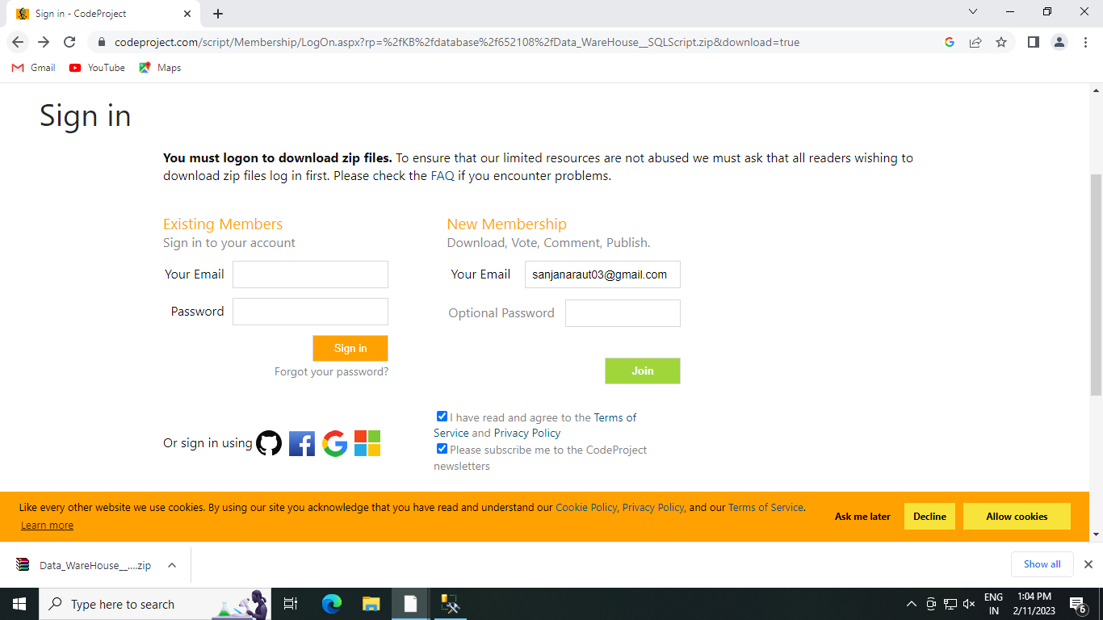

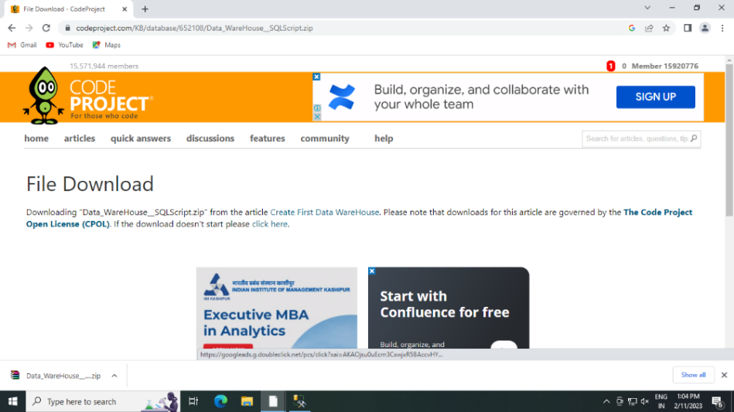

**After downloading extract file in folder.**

1. **Follow the given steps to run the query in SSMS (SQL Server Management Studio).**
2. **Open SQL Server Management Studio 2012**
3. **Connect Database Engine .**
4. **Open new Query editor**
5. **Go to extracted sql file and double click on it .**
6. **New sql Query Editor will be opened Containing Sales_DW Database .**
7. **Click on execute or press F5 by selecting query one by one or directly on Execute.**
8. **After completing execution save and close SQL Server Management Studio & Reopen to see Sales_DW In Databases Tab .**

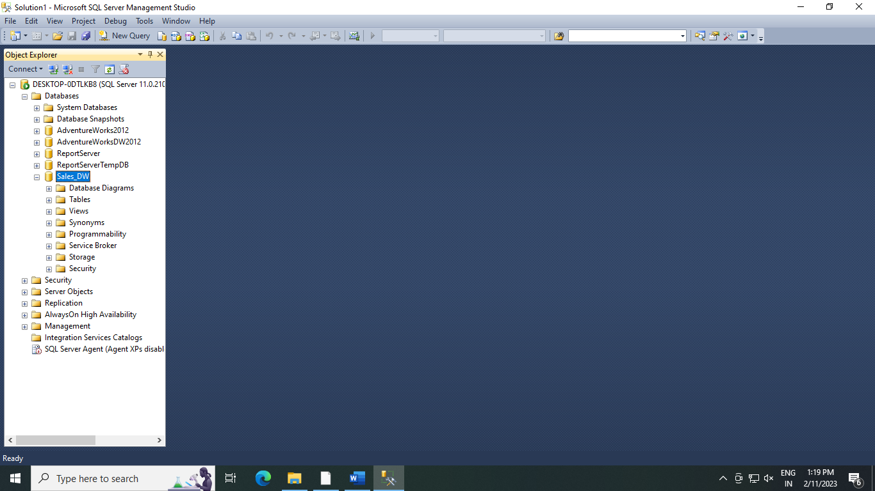

1. **Start SSDT environment and create New Data Source .**
2. **Go to Sql Server Data Tools 🡪 Right click and run as administration**
3. **Click on File -> New -> Project**

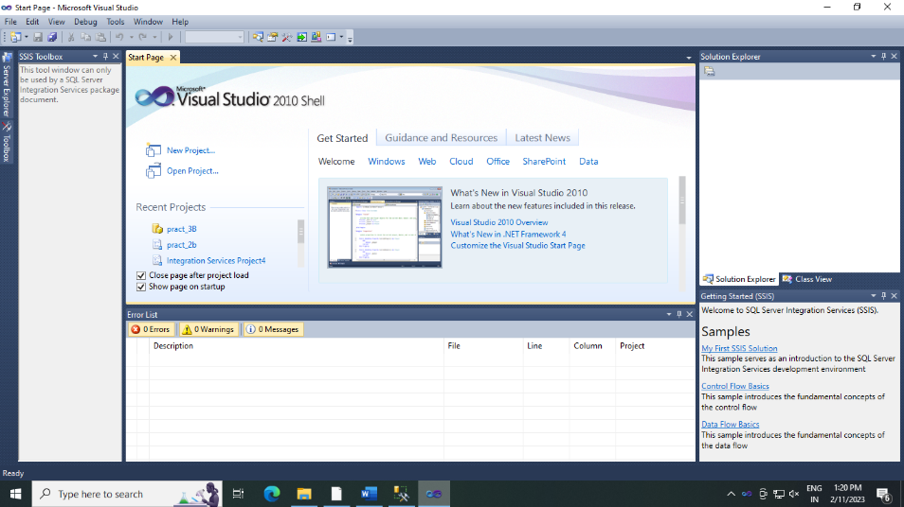

1. **In Business Intelligence -> Analysis Services Multidimensional and Data Mining Models -> Appropriate Project Name -> Click ok .**

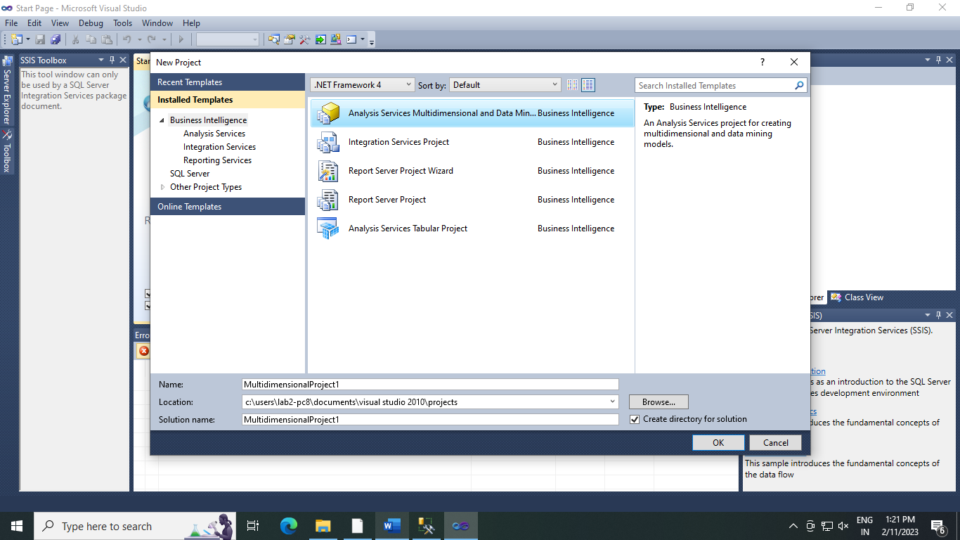

1. **Right Click on Data Sources in soln Explorer -> New Data Source .**

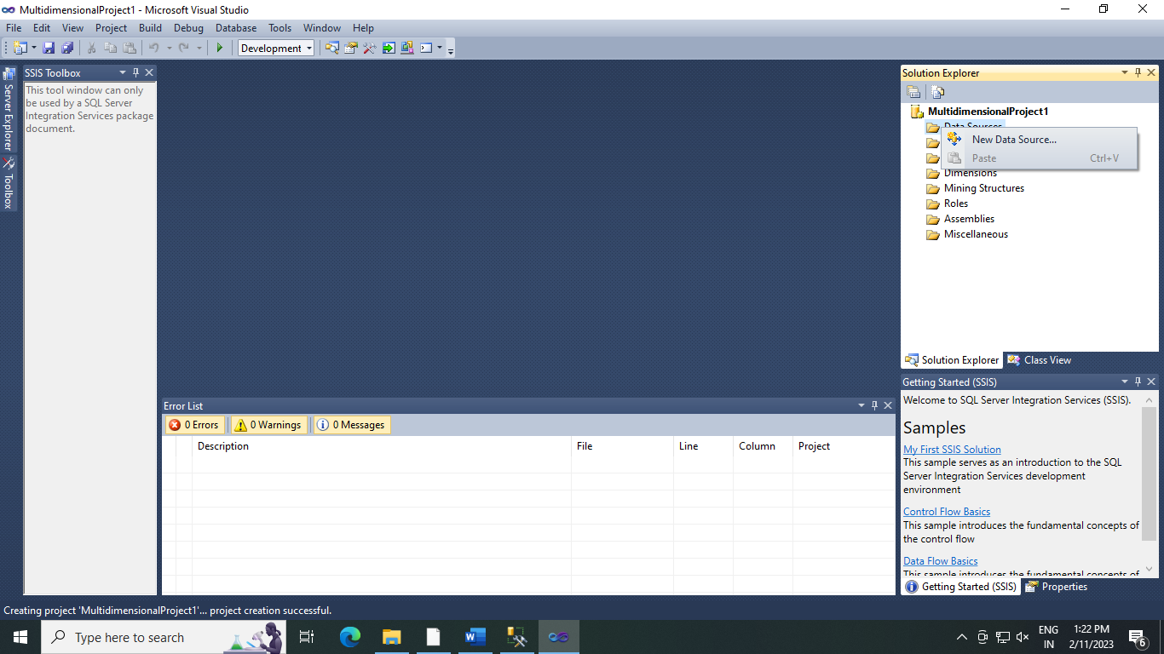

1. **Data Source Wizard appears**

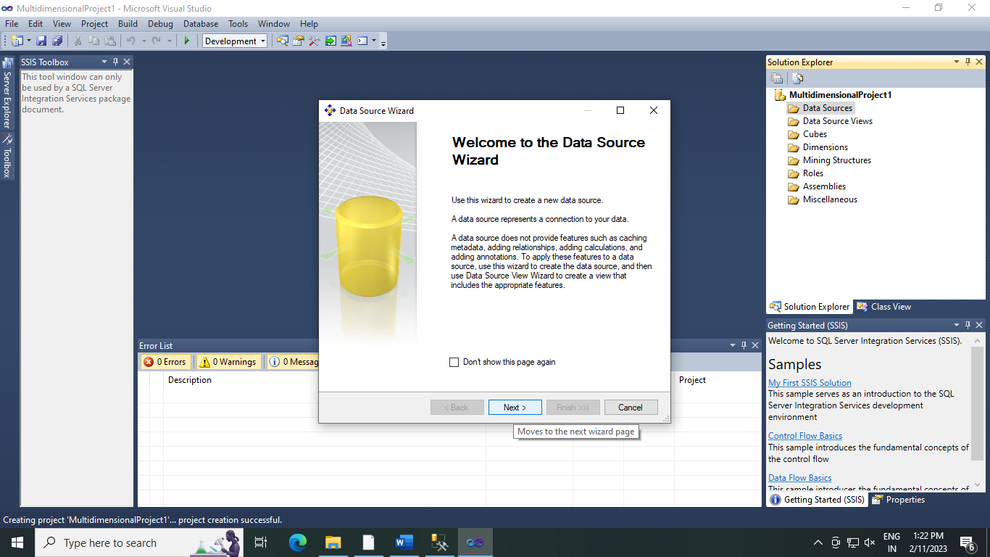

1. **Click on new**

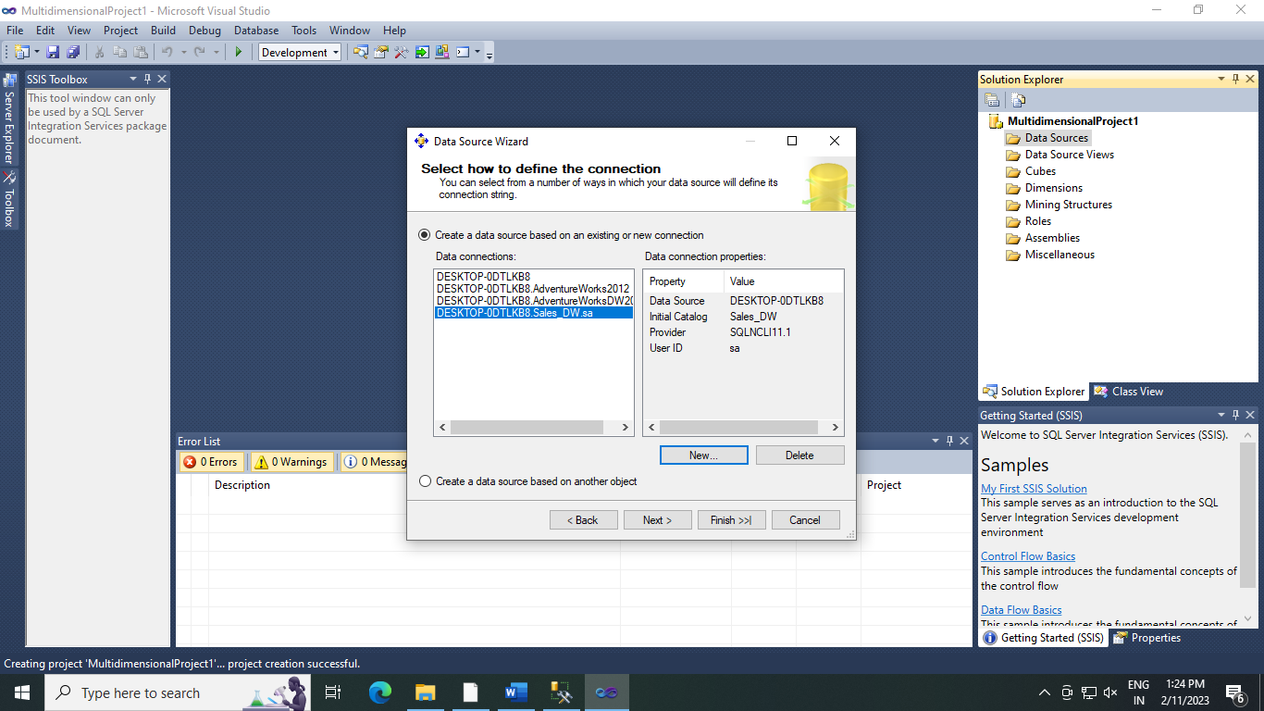

1. **Select Server Name -> select use of SQL Server Authentication -> Select or enter a database name (Sales_DW)**

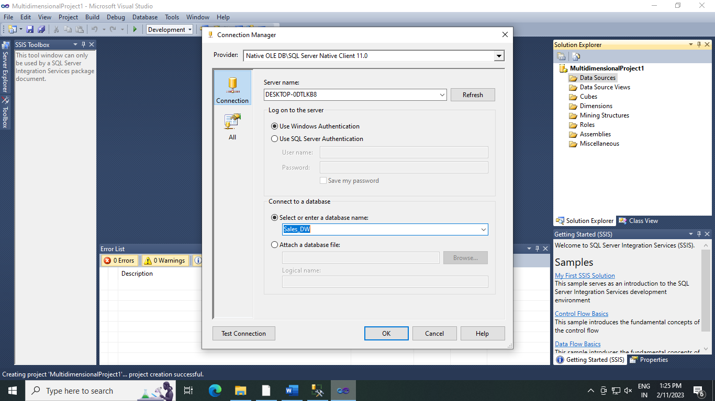

1. **Click Next .**

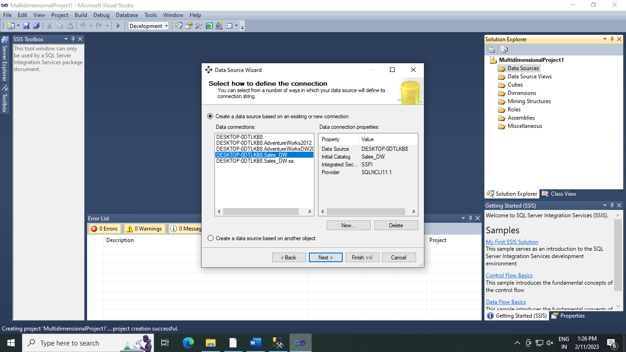

1. **Select Inherit -> Next**

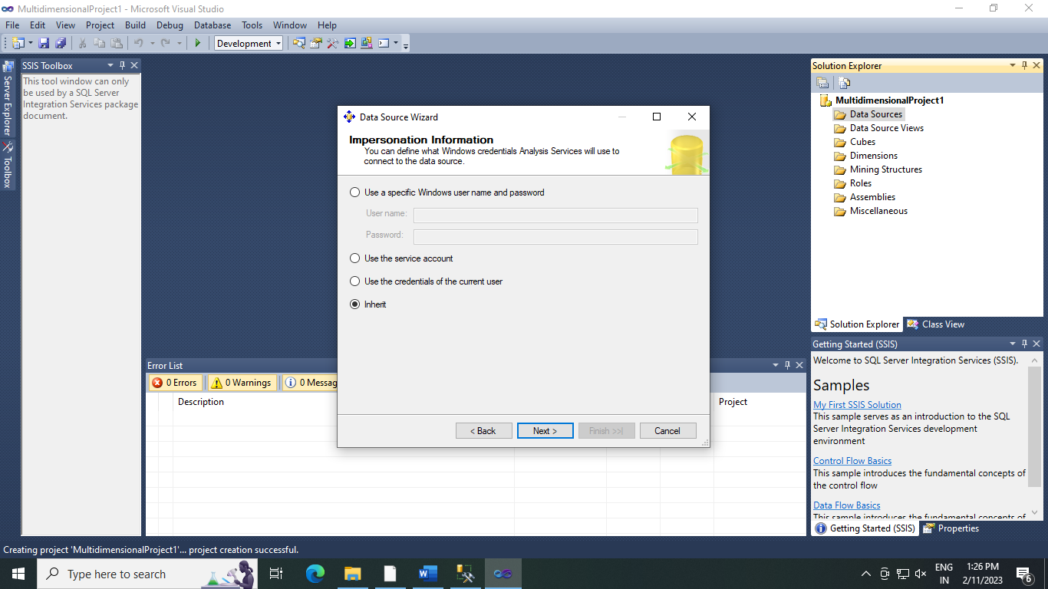

1. **Click on Finish**

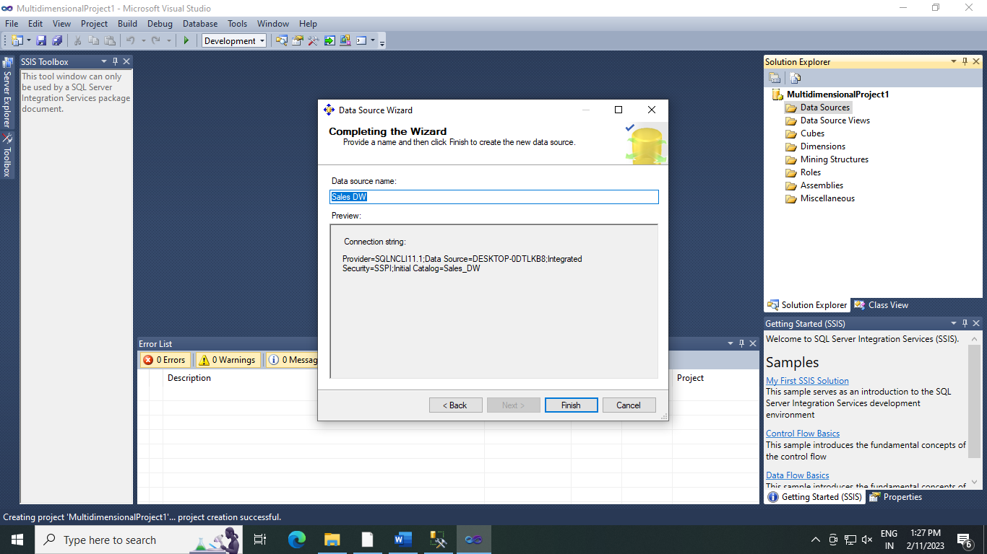

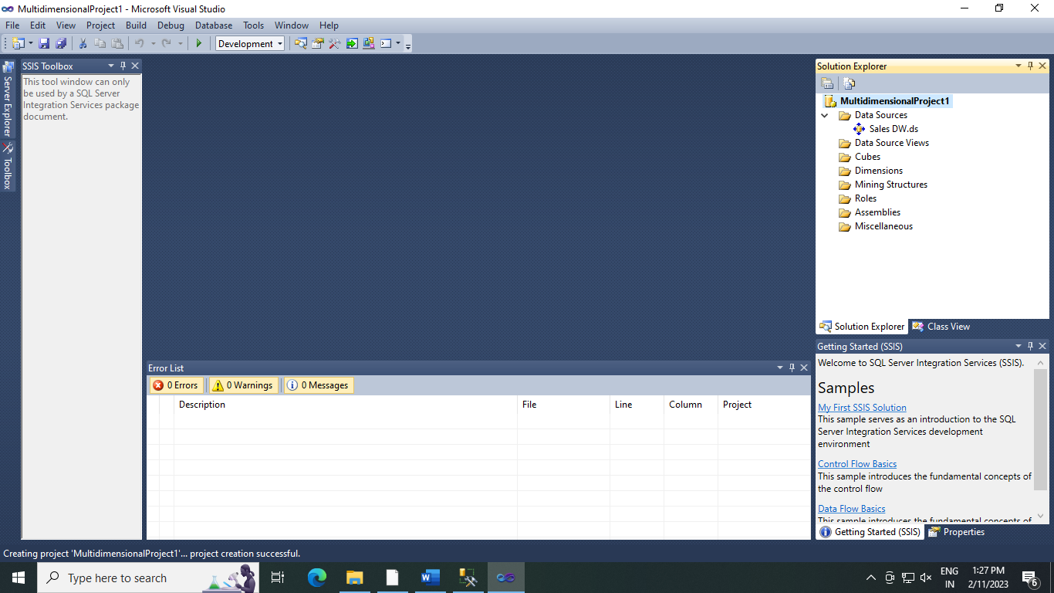

1. **Creating New Data Source View  
   1. Right Click on Data Source View in soln Explorer -> New Data Source View .**

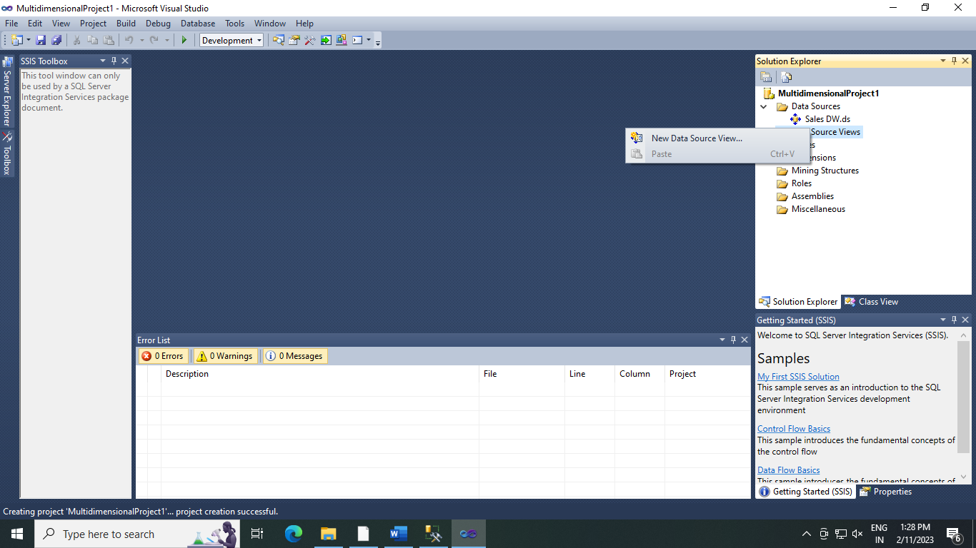

**2.Click Next -> Again Next**

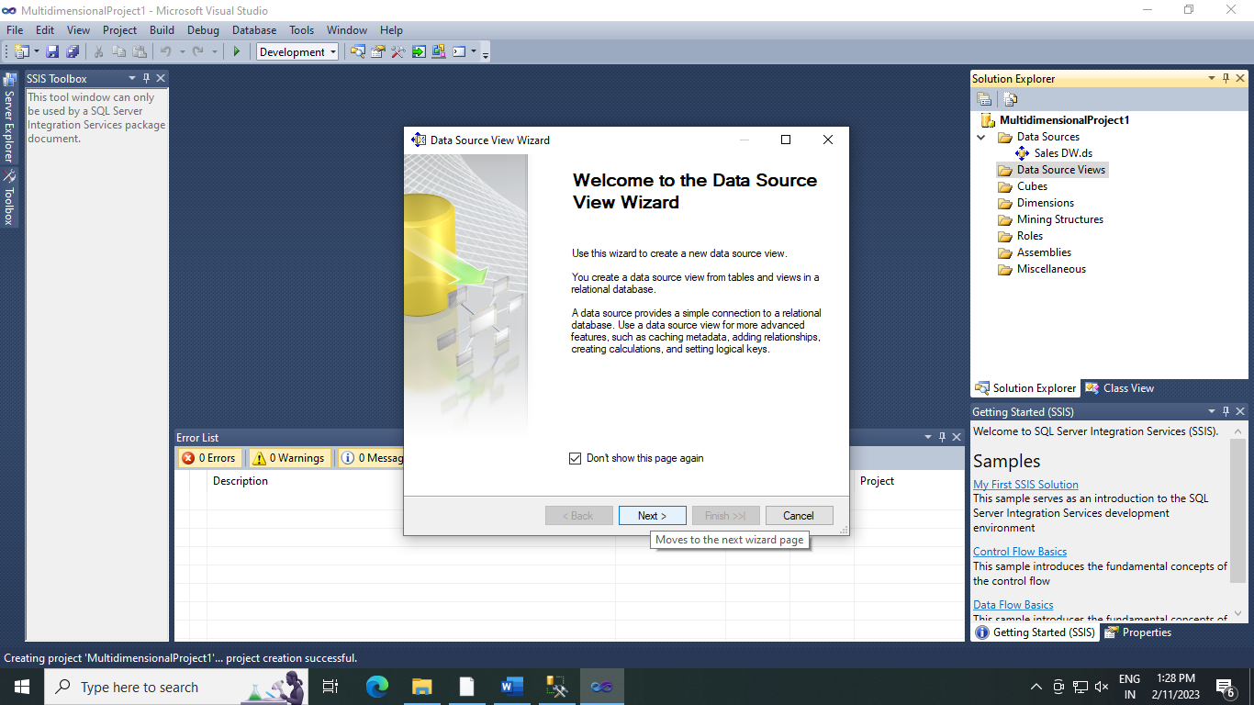

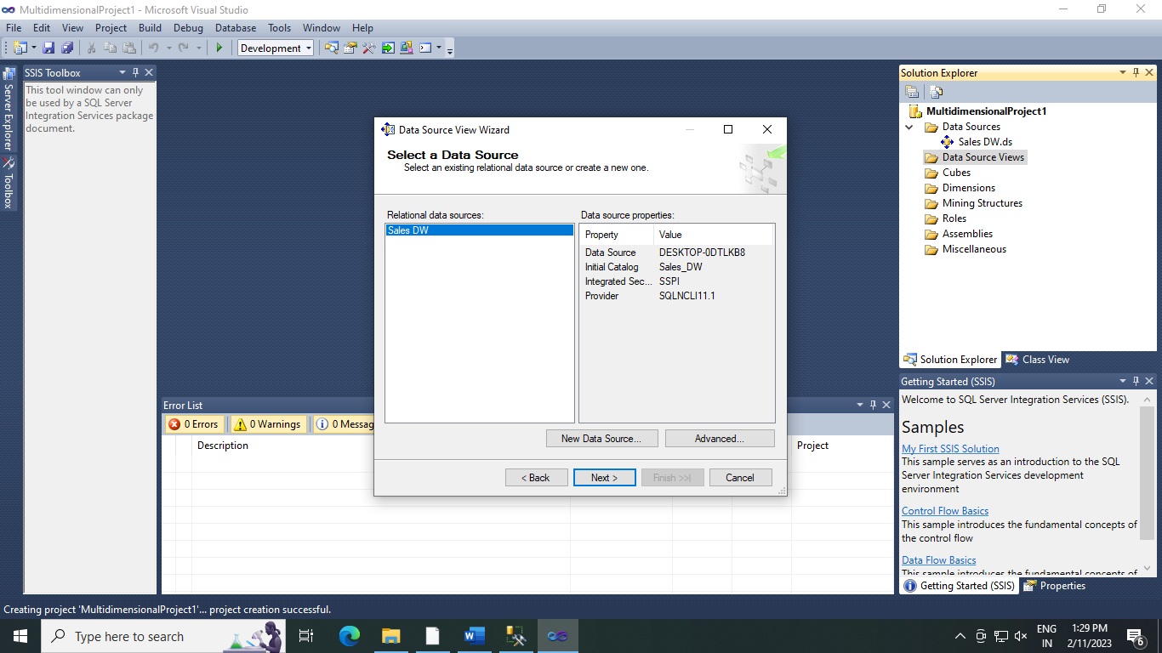

**3.Select FactProductSales (dbo) from Available objects and put in Includes Objects by clicking on 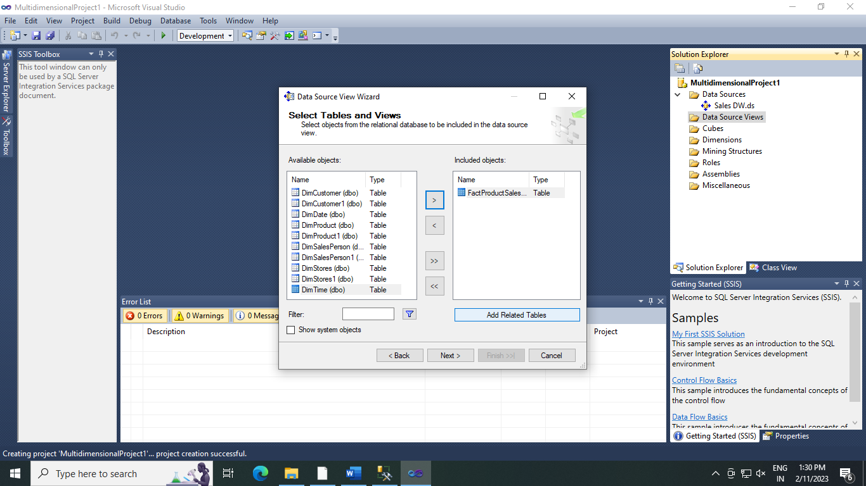 .**



**4. Click on Add Related Tables .**

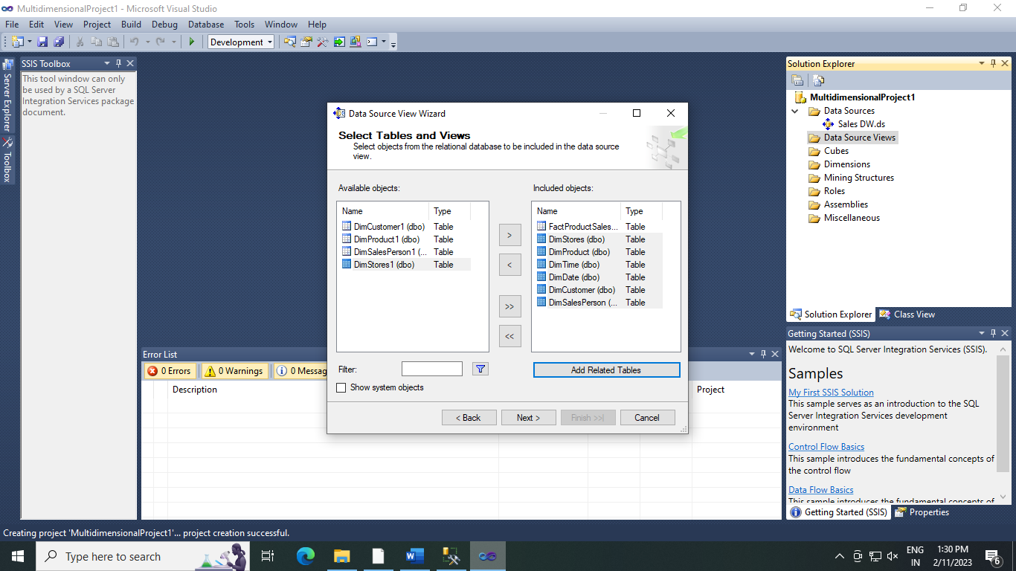

**5.Click Next .**

**6. Click Finish .**

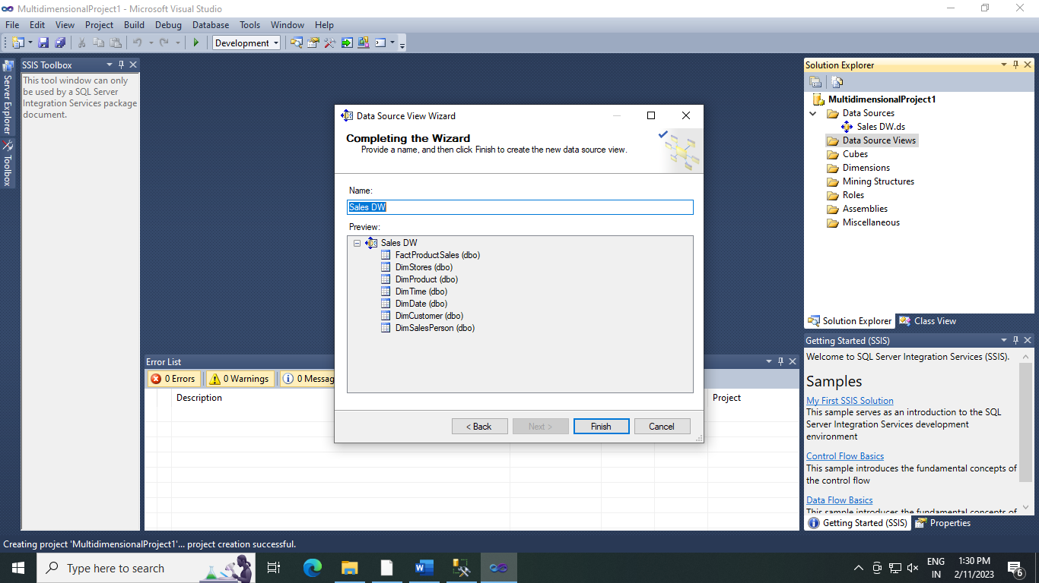

1. **Sales DW.dsv appears in Data source Views in Soln Explorer.**

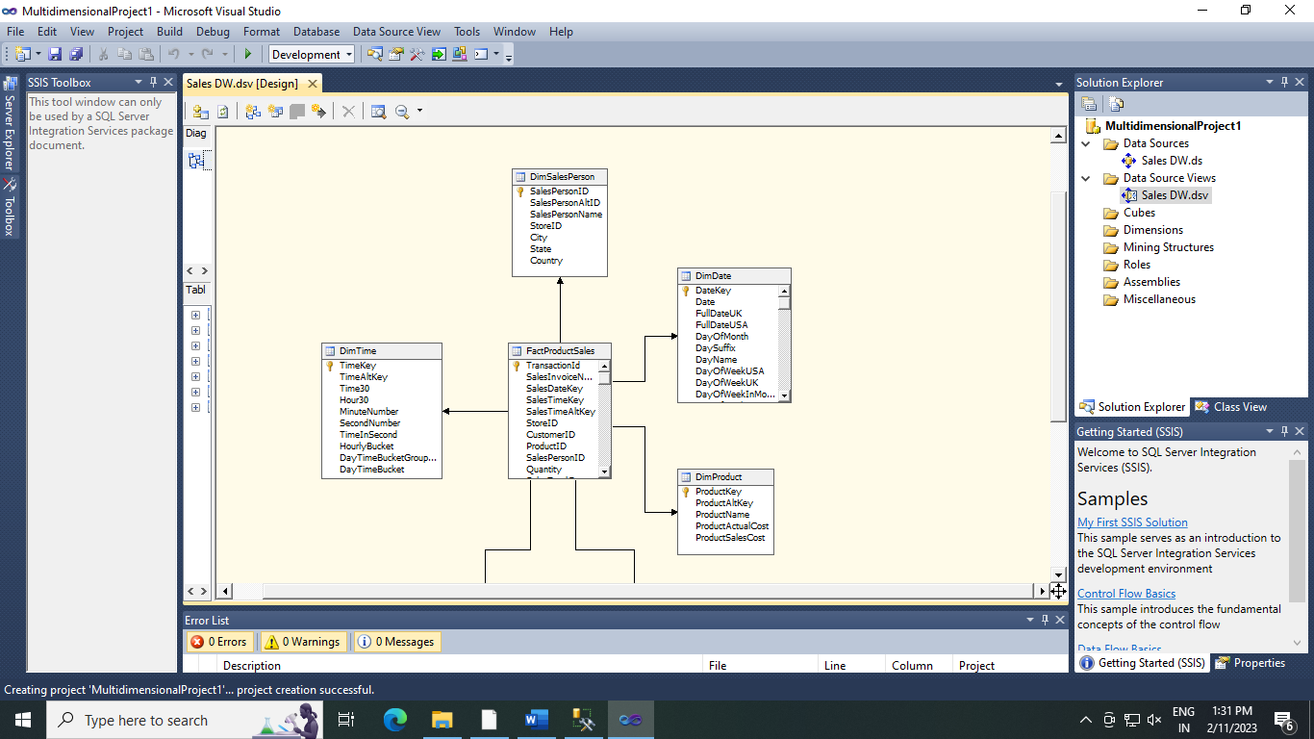

**8) Creating New cube .**

1. **Right click on cubes -> New Cubes**

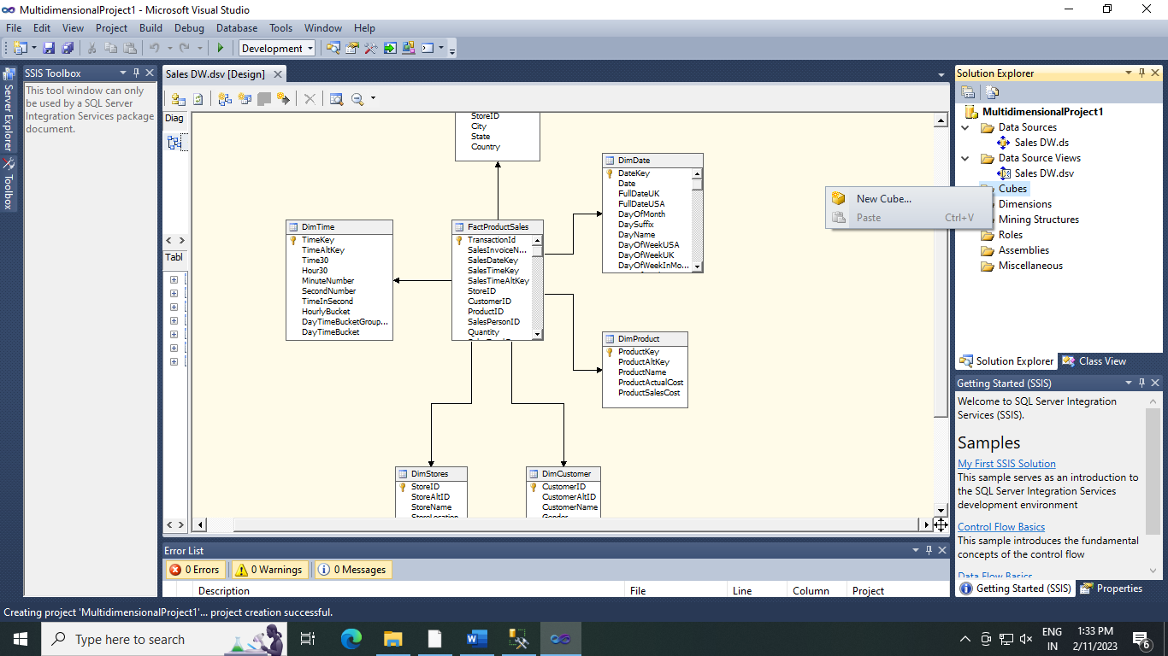

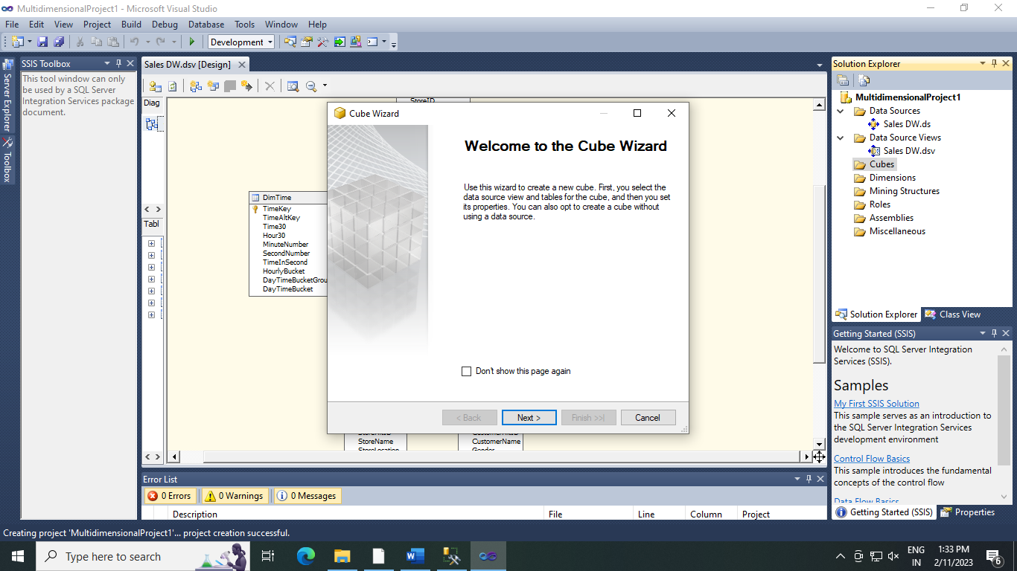

1. **Select Use existing tables in Select Creation Method -> Next .**

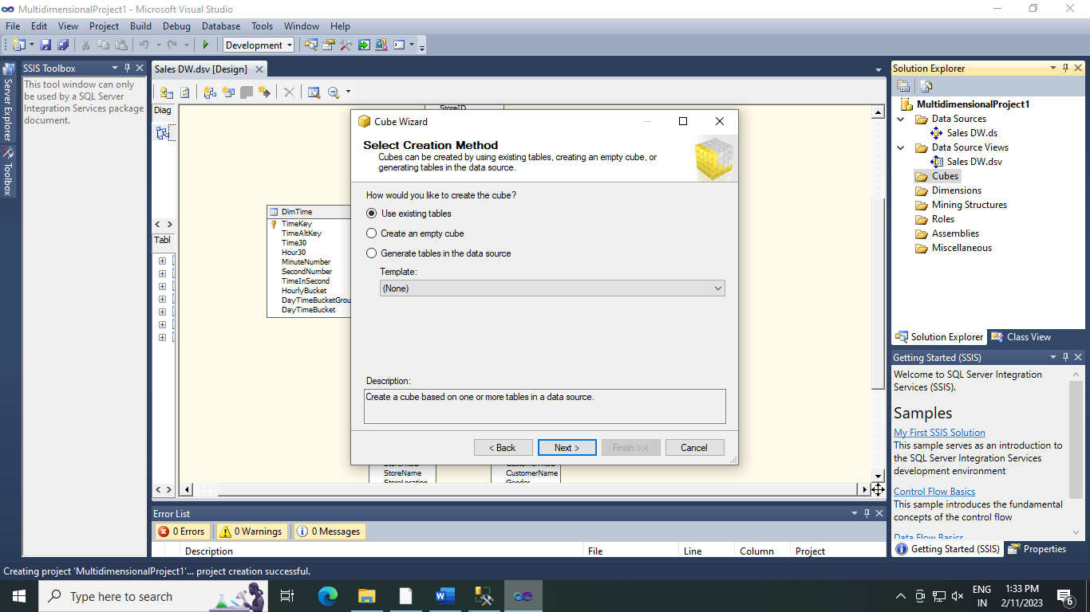

1. **In Select Measure Group Tables -> Select FactProductSales -> Click Next .**

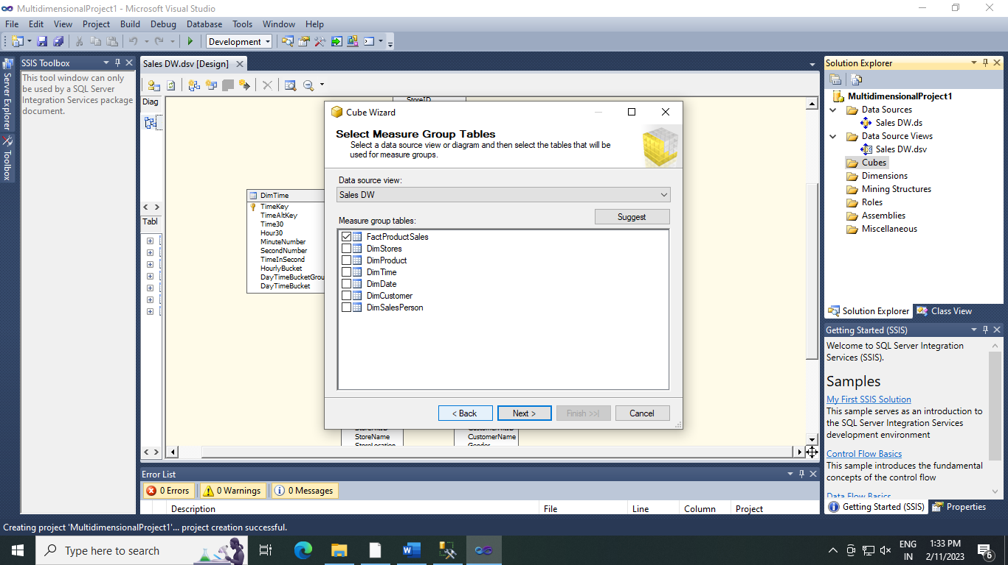

1. **Selct Measure -> Check all Measure -> Next .**

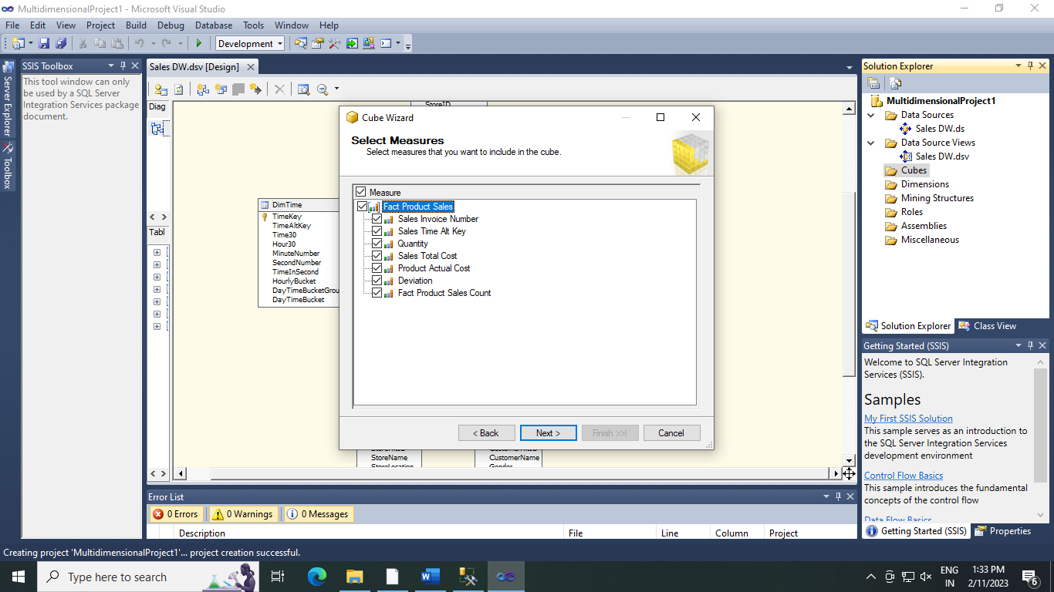

1. **In Select New Dimensions -> Check all Dimensions -> Next .**

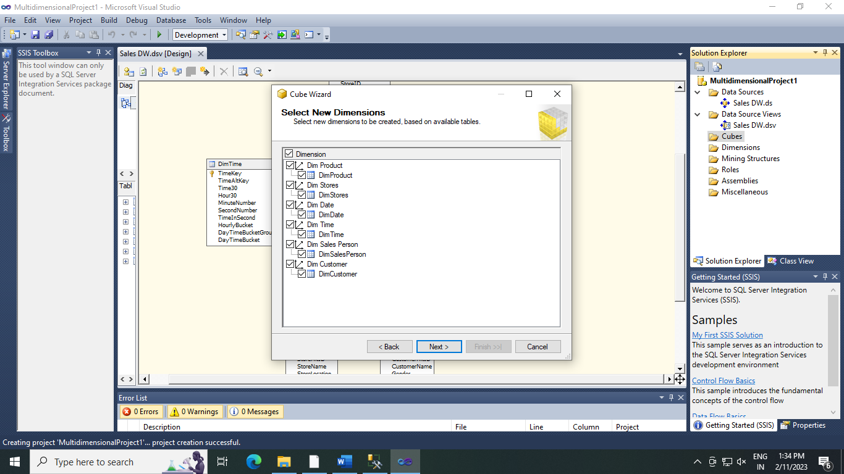

1. **Click on Finish .**

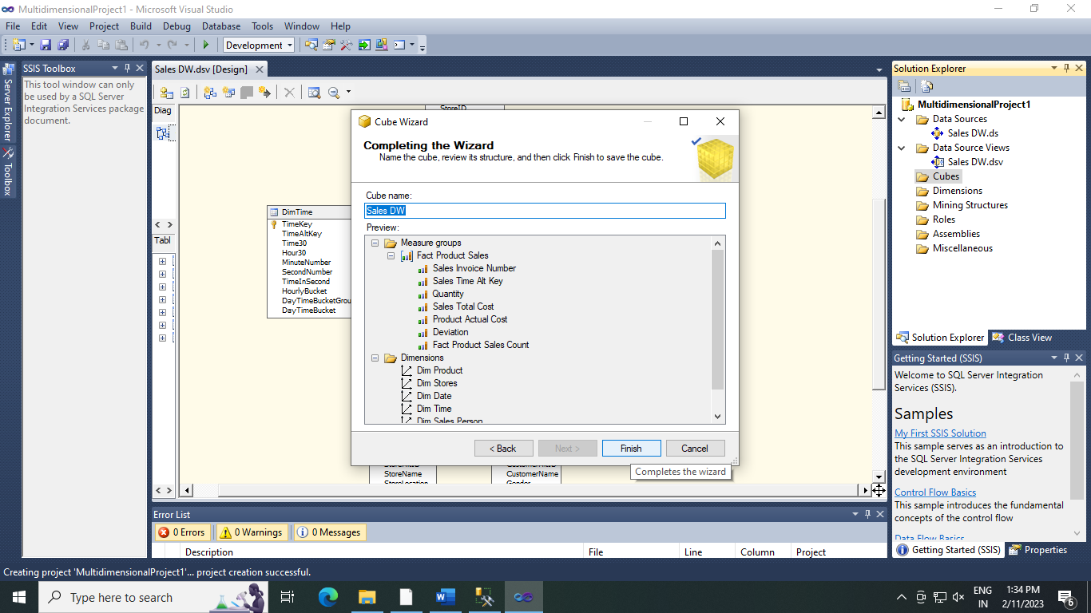

1. **Sales_DW cube is created**
2. **Dimension Modification**
3. **In dimesion Tab -> Double Click Dim Product.dim**

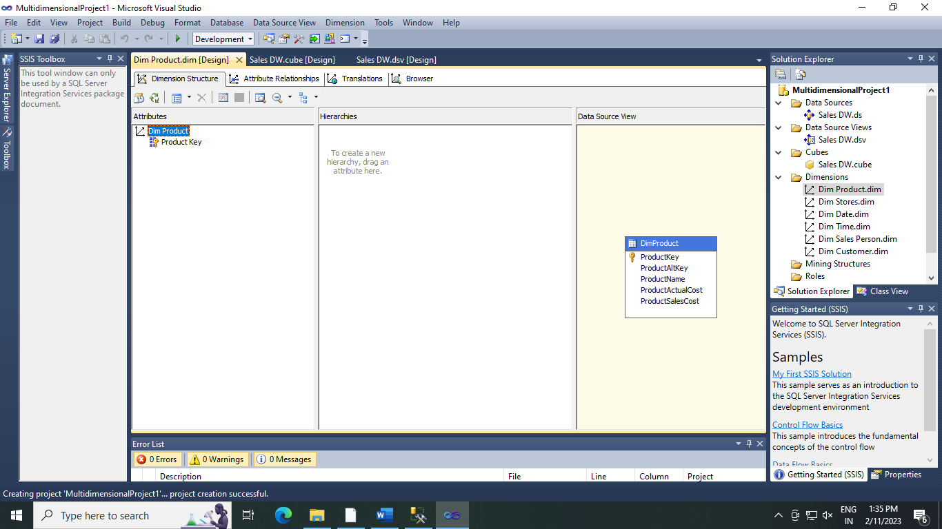

1. **Drag and Drop Product Name from Table in Data Source View and Add in Attribute Pane at Left Side.**

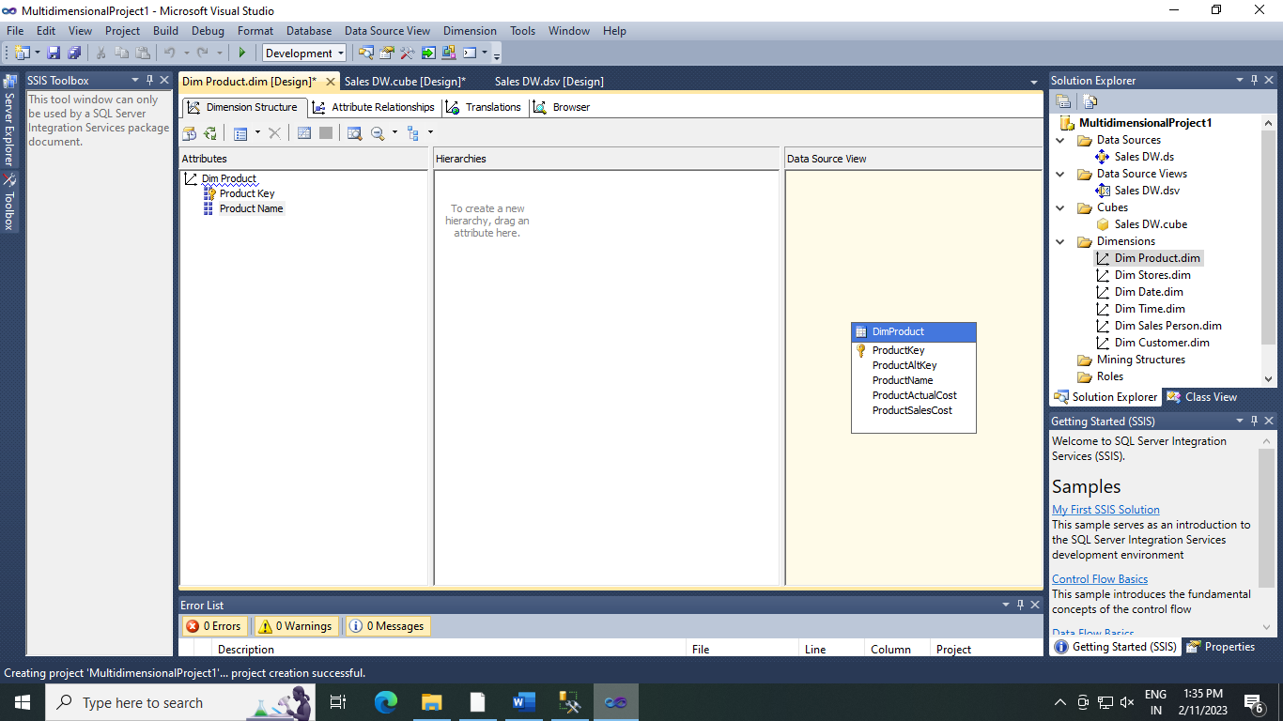

.

1. **Creating attribute Hierarchy in Data Dimension .**
2. **Double Click on Dim Data Dimension -> Drag and Drop Fields From Table shown in Data Source View Attributes -> Drag and Drop Attributes from leftmost pane of attribute to middle pane of Hierarchy**

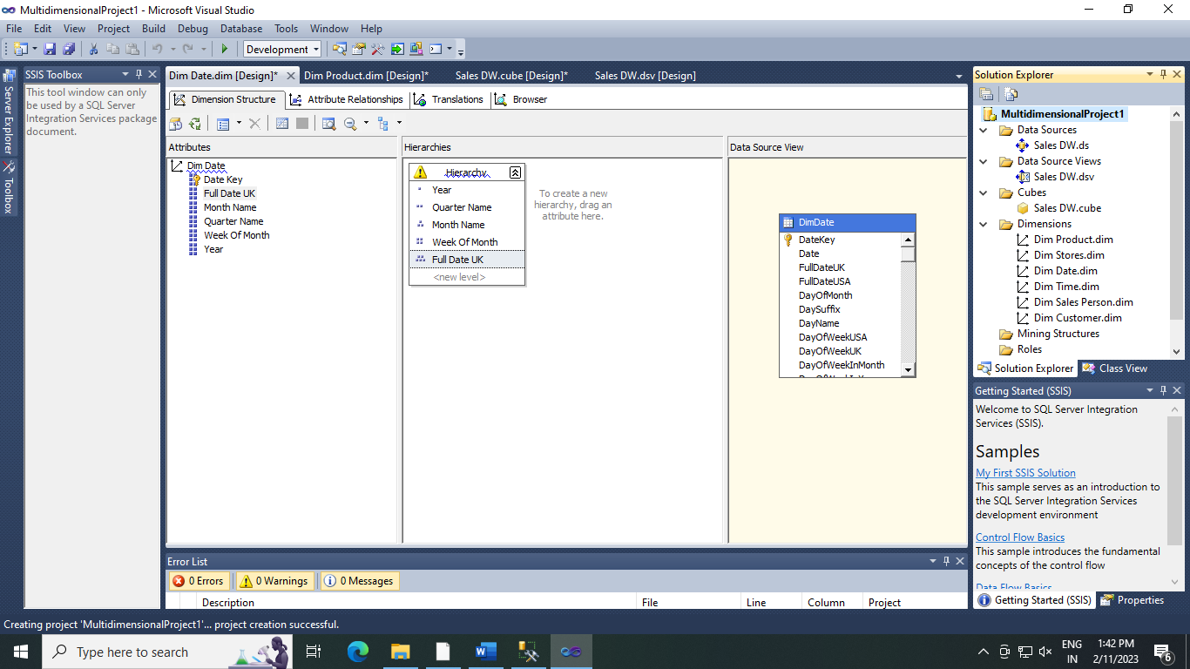

1. **Deploy Cube**

**Right click on Project Name -> Properties .**

**Do following Changes**

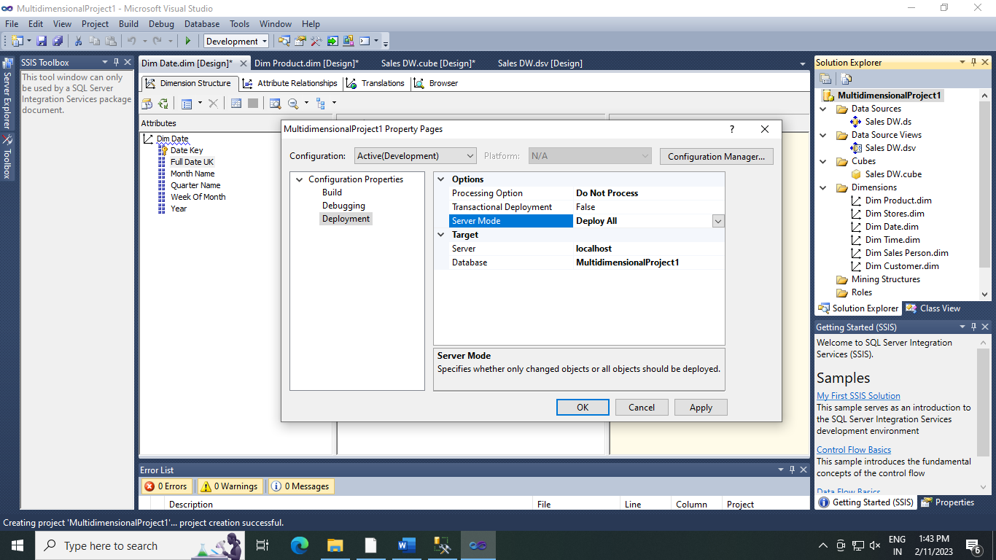

**Right Click on Project Name -> Deploy**

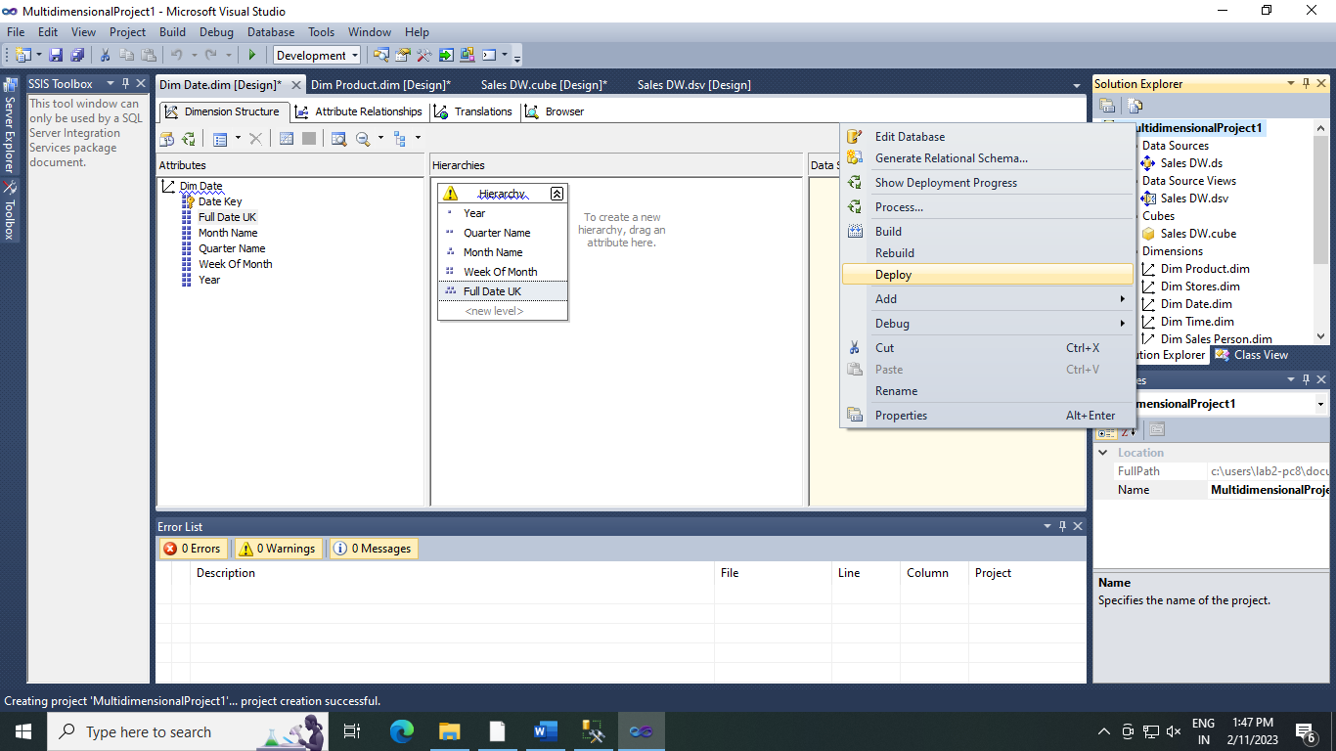

**Deployment Successful**

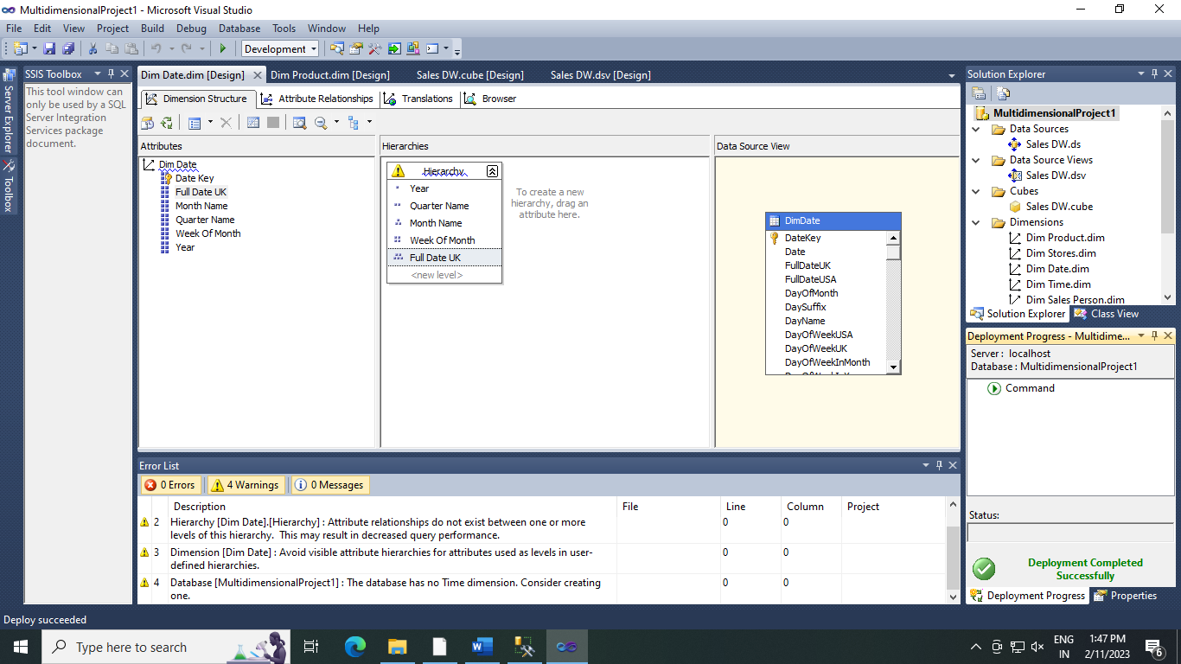

**To Process cube right click on Sales_DW.cube -> Process**

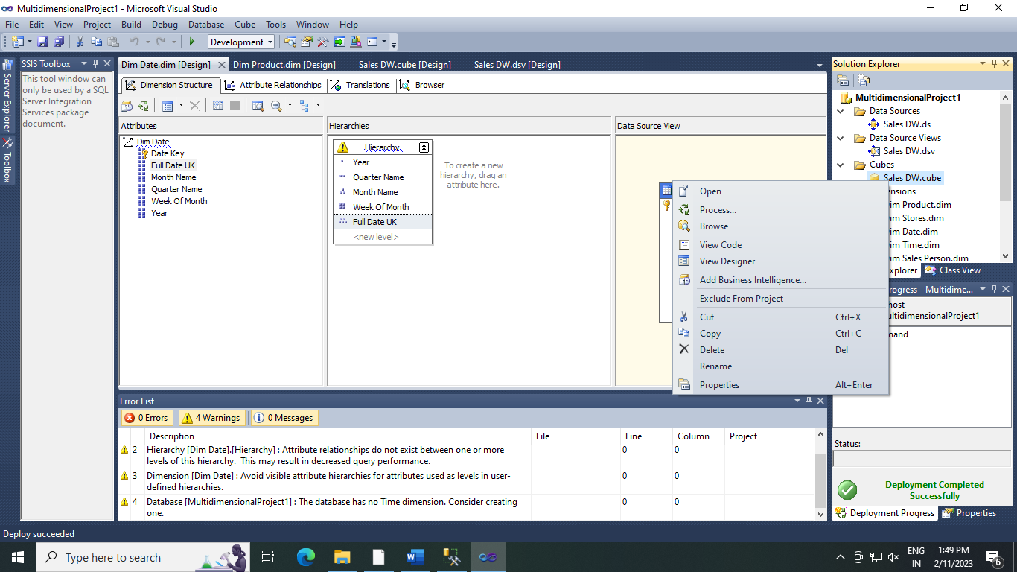

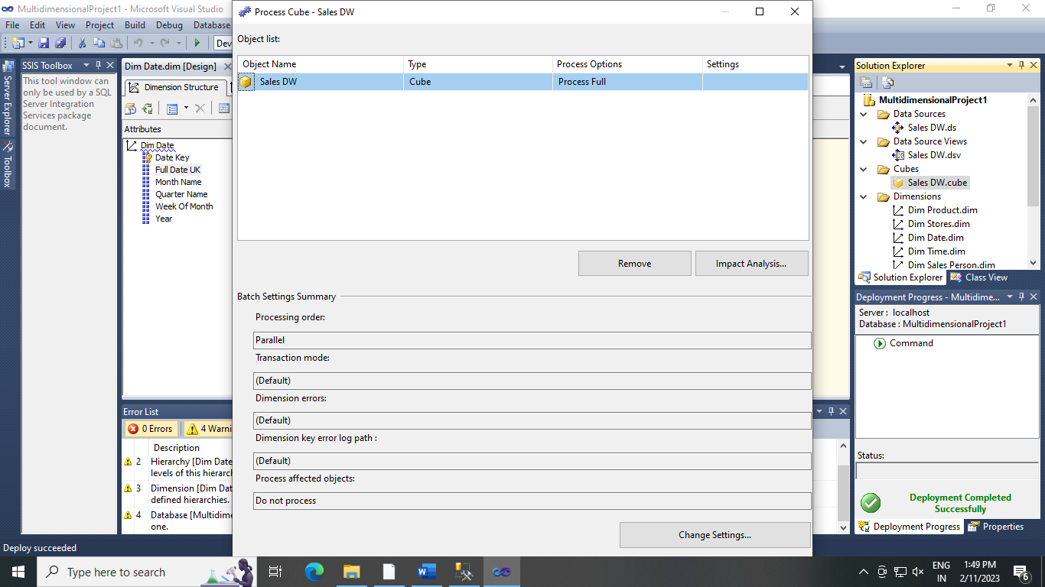

**Click on Run**

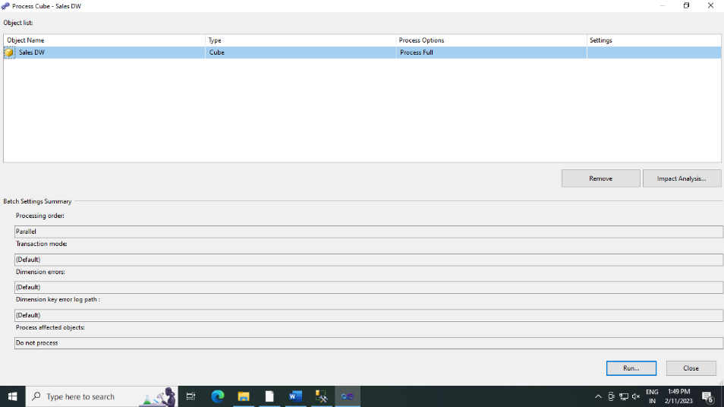

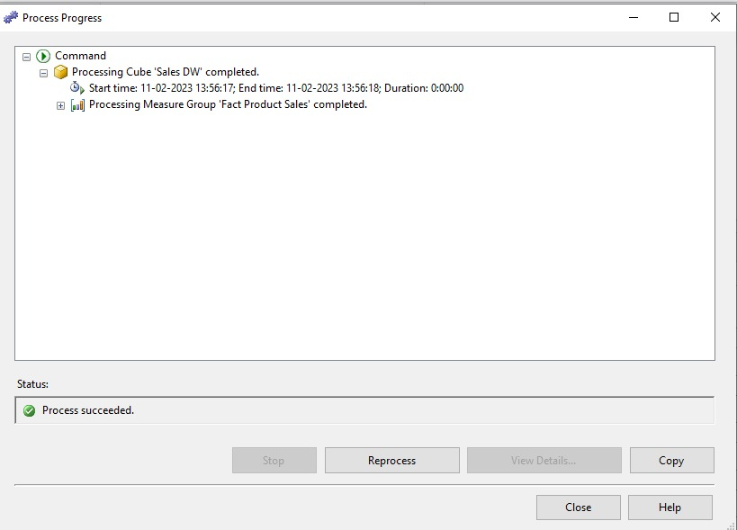

**Practical 4 :-Execute the MDX Queries to extract the data from data warehouse .**

**Steps :-**

1. **Open Sql Server Management Studio and connect to Analysis Services.**

**Server type :- Analysis Services**

**Click on Connect .**

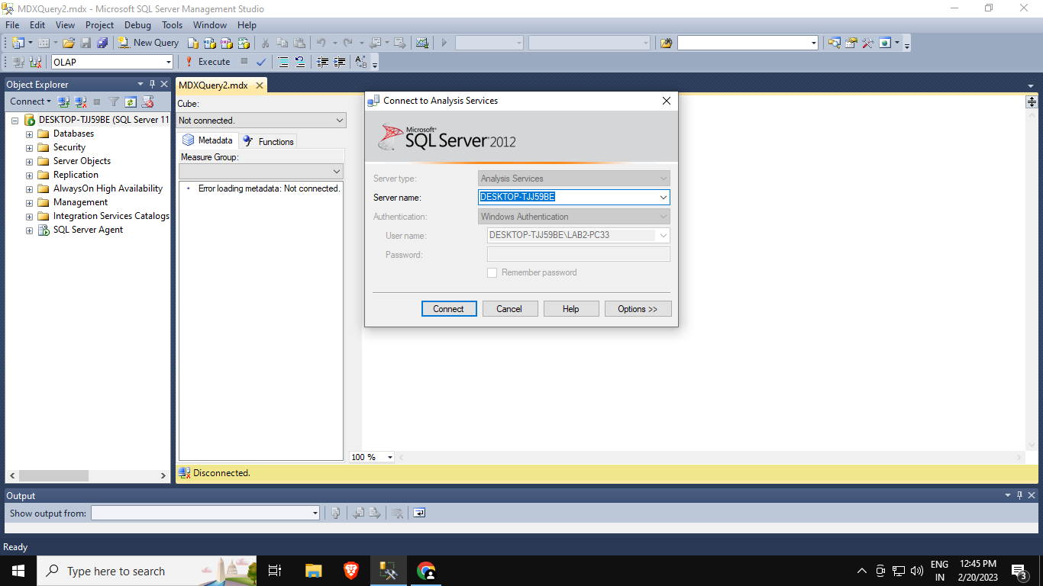

1. **Click on New Query & type following query based on Sales_DW**

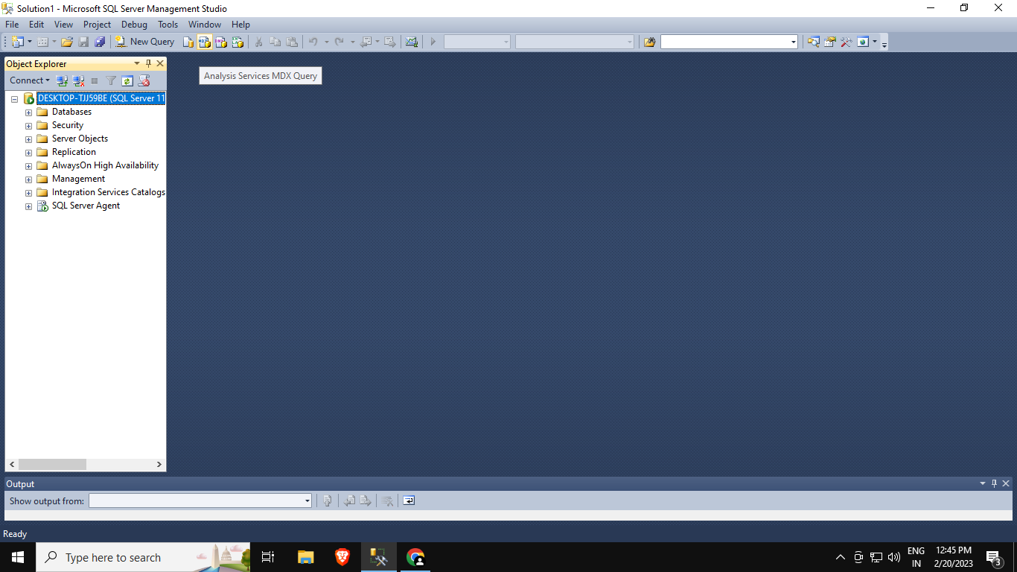

**Query :-**

select[Measures].[Sales Time Alt Key] on columns

from [Sales DW]

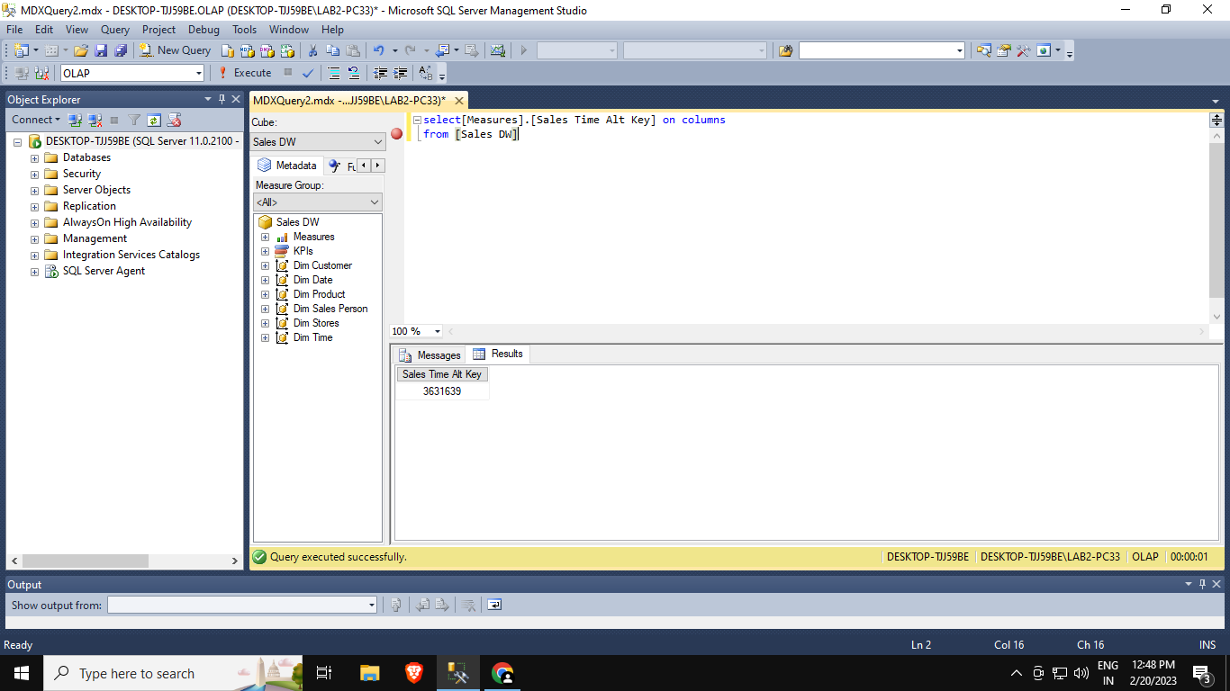

select[Measures].[Quantity] on columns

from [Sales DW]

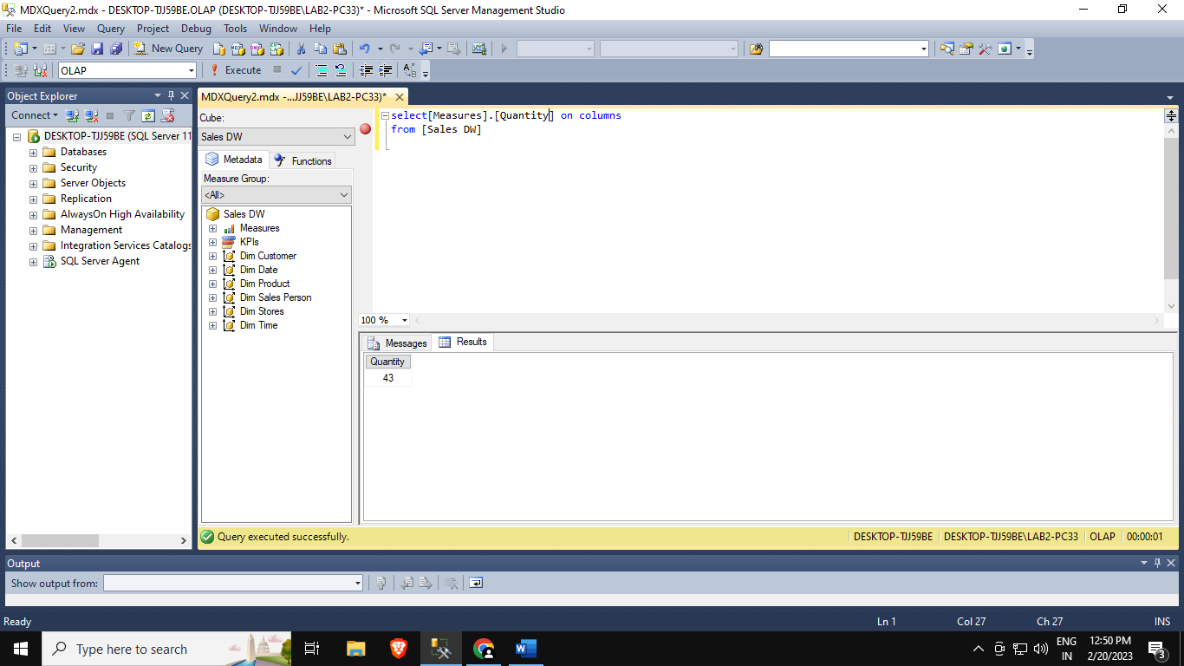

select[Measures].[Sales Invoice Number] on columns

from [Sales DW]

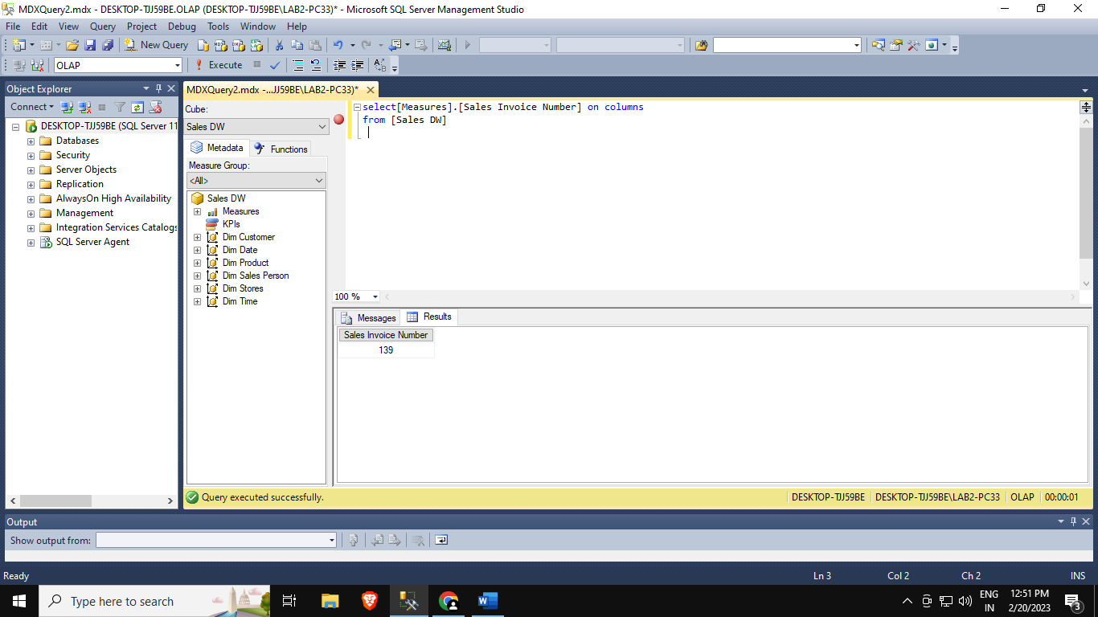

select[Measures].[Sales Total Cost] on columns

from [Sales DW]

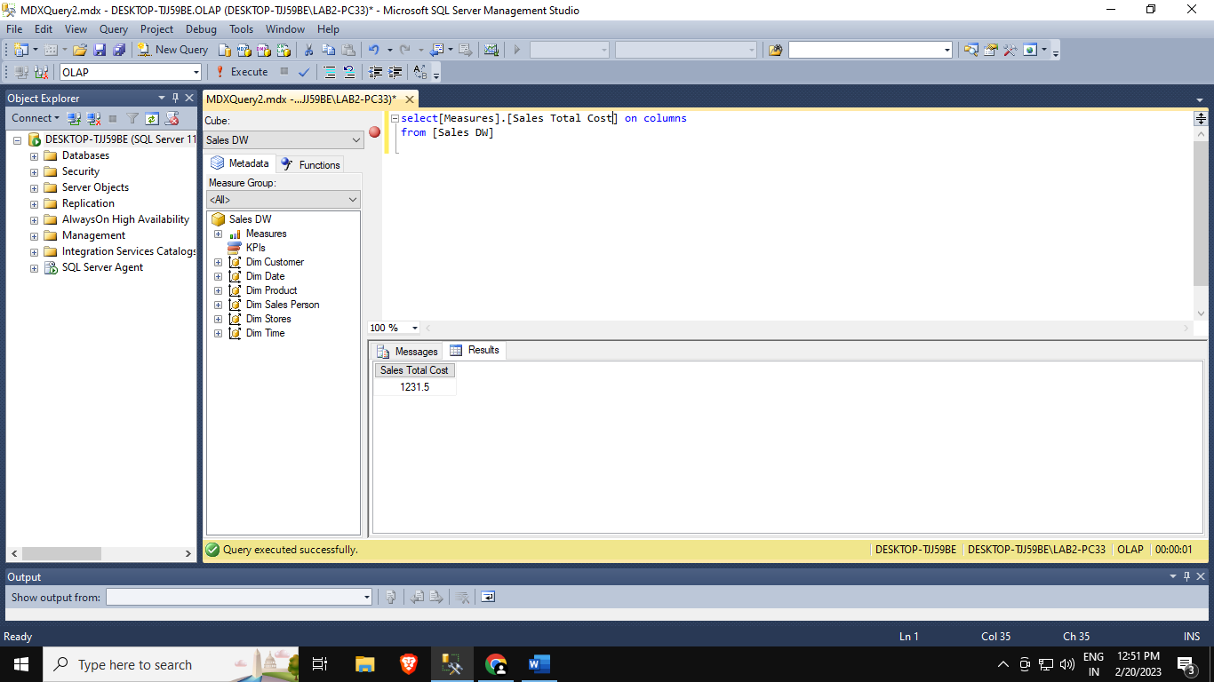

select[Measures].[Sales Total Cost] on columns

,[Dim Date].[Year].[Year] on rows

from [Sales DW]

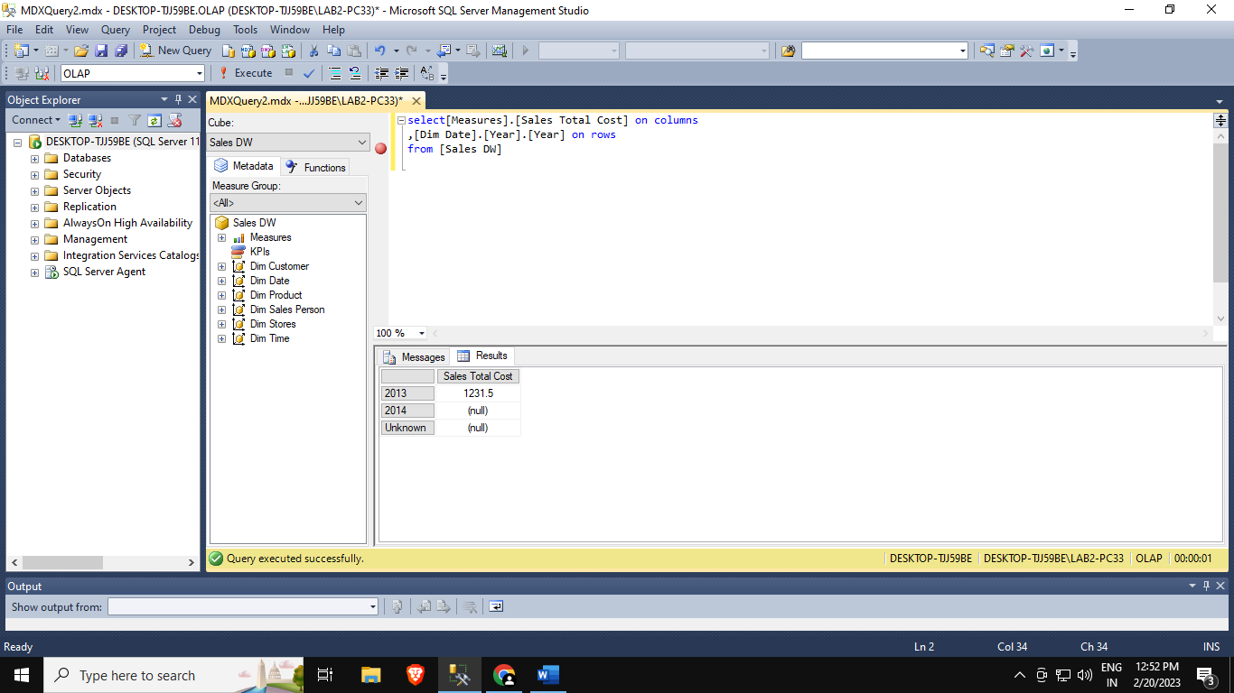

select[Measures].[Sales Total Cost] on columns

,NONEMPTY({[Dim Date].[Year].[Year]}) on rows

from [Sales DW]

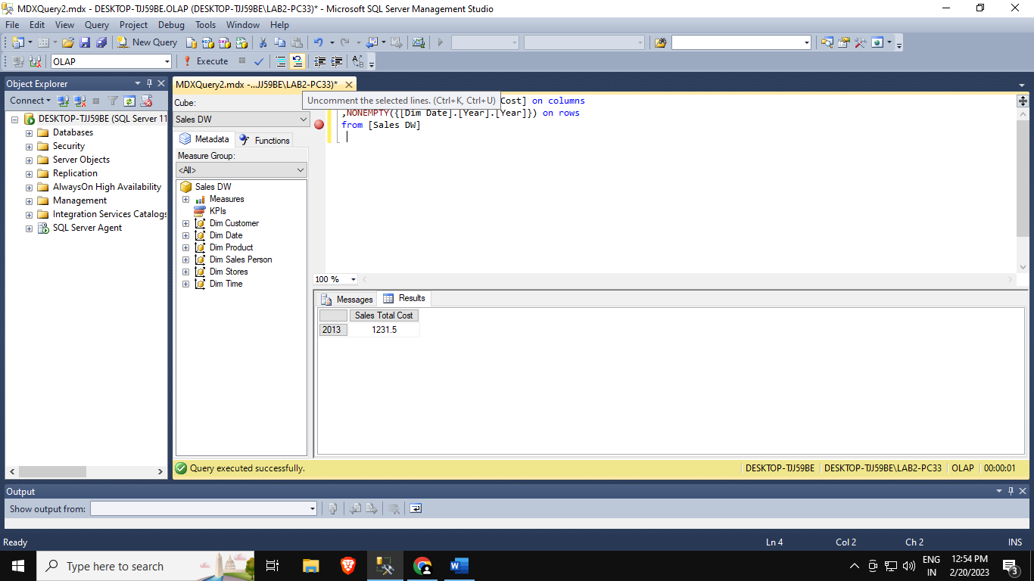

select[Measures].[Sales Total Cost] on columns

from [Sales DW]

Where [Dim Date].[Year].[Year] &[2013]

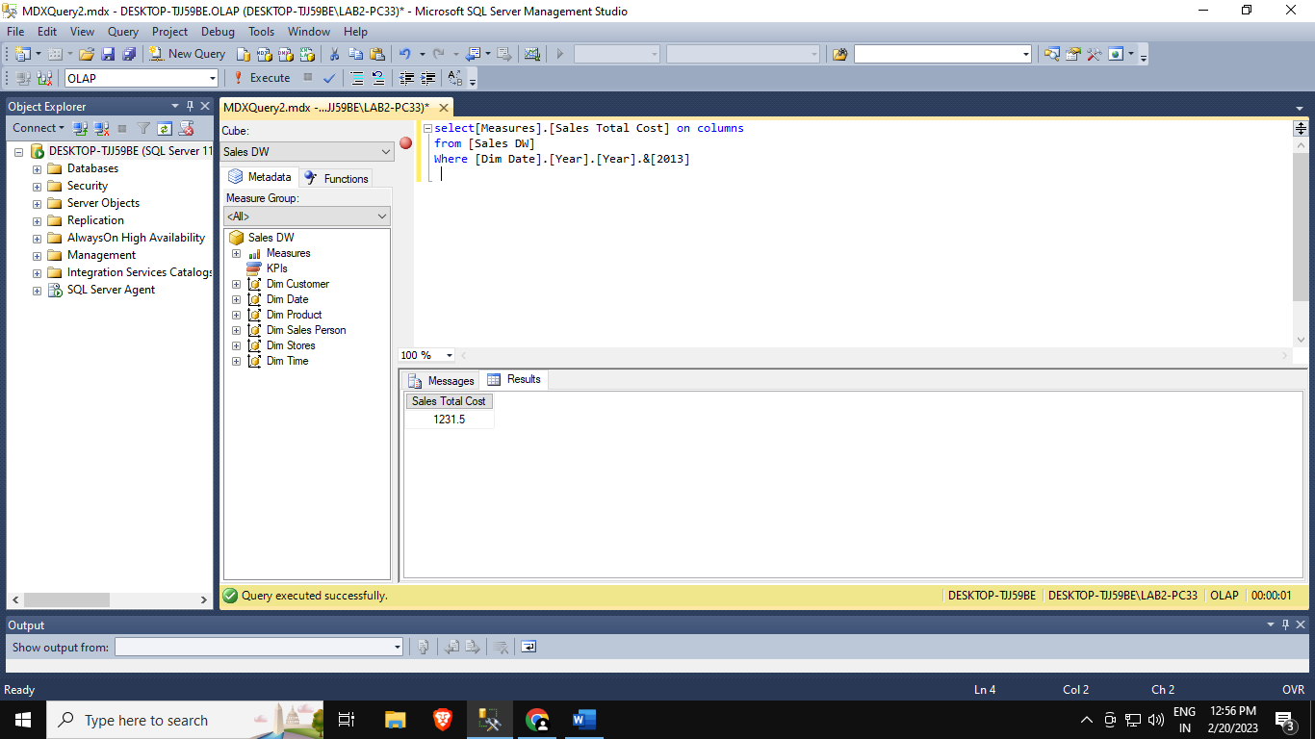

**Practical 5a :-Import the datawarehouse data in Microsoft Excel and create the Pivot table**

**Step 1: Open Excel 2013 (Professional)**

**Go to Data tab → From Database → From Data Analysis Services**

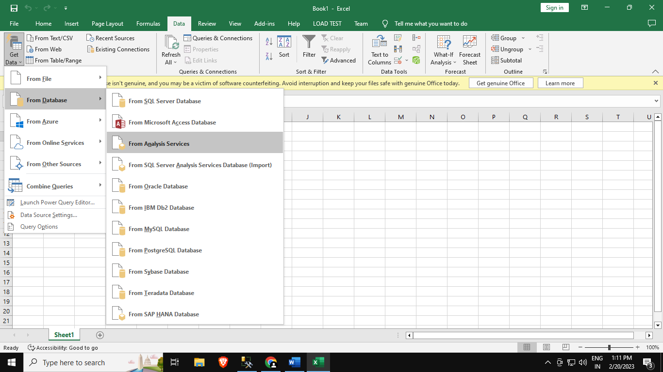

**2: In Data Connection Wizard →→ Select Microsoft SQL Server → Click on next**

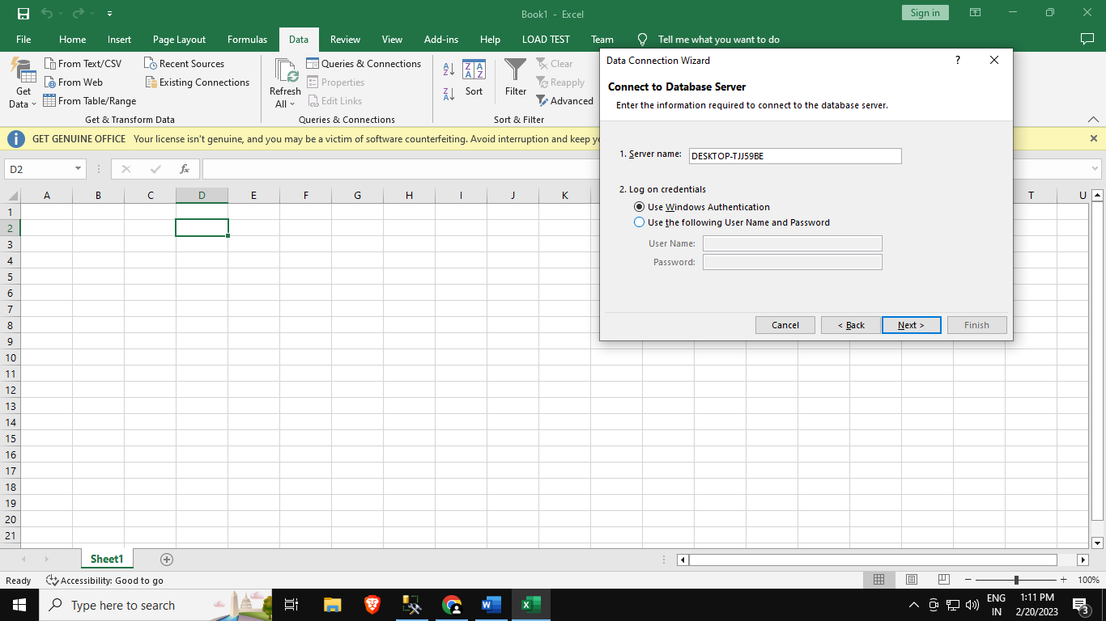

**Step 3: In connect to Database Server provide Server name( Microsoft SQL Server Name)**

**Click on Next**

**Step 4: In Select Database and Table→ Select Sales_DW (already created in SQL) → check all dimensions and import relationships between selected Tables**

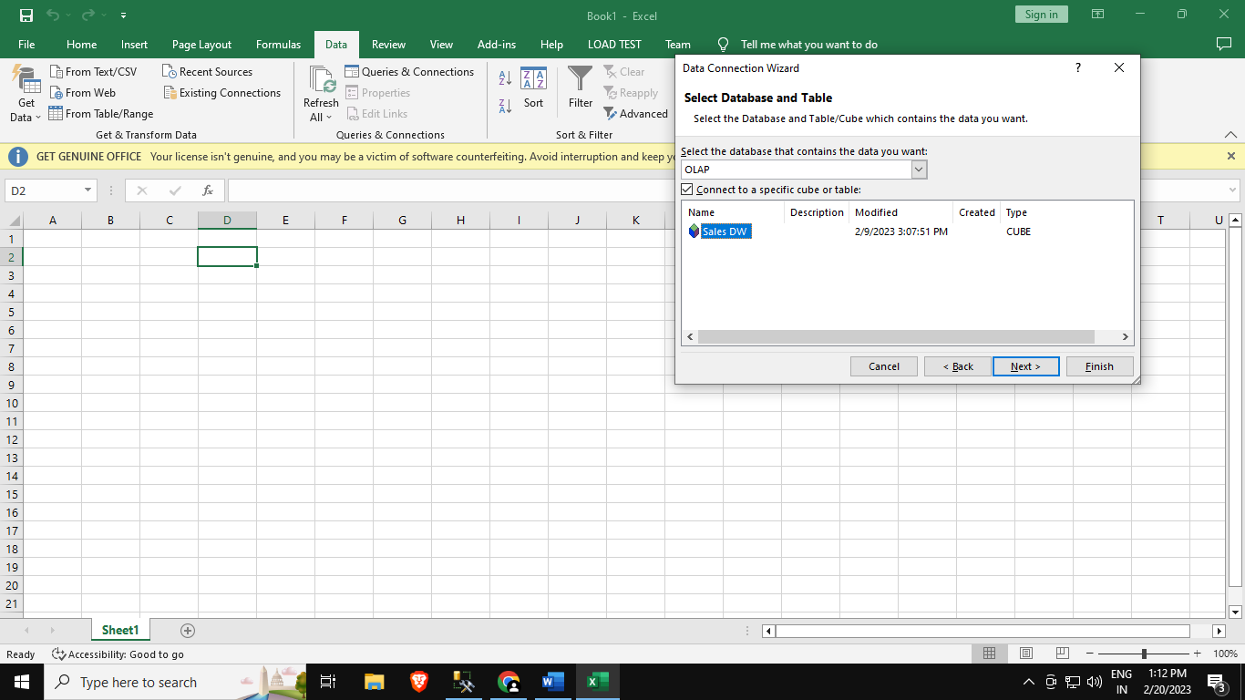

**Step 5: In save data connection files browse path and click on Finish**

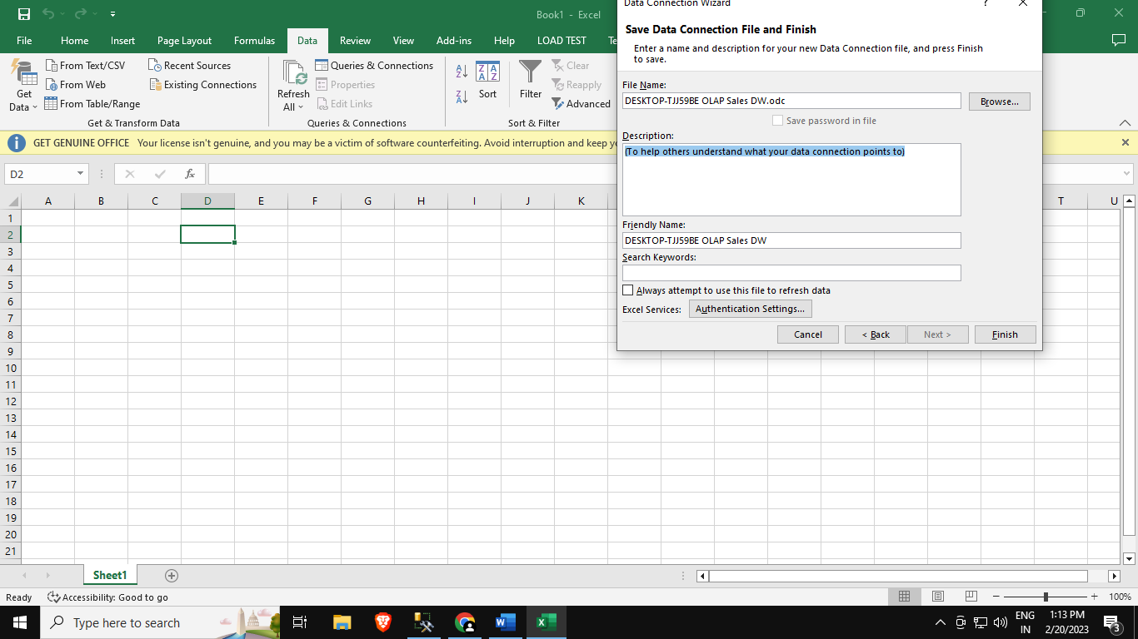

**Step 6: In import data select Pivot Chart and click on OK**

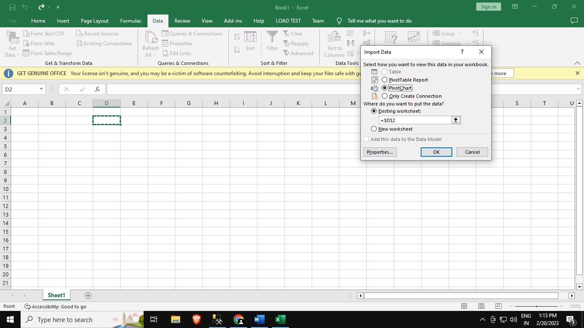

**Step 7: In fields put SalesDateKey in filters, FullDateUK in axis and Sum of ProductActualCost in values**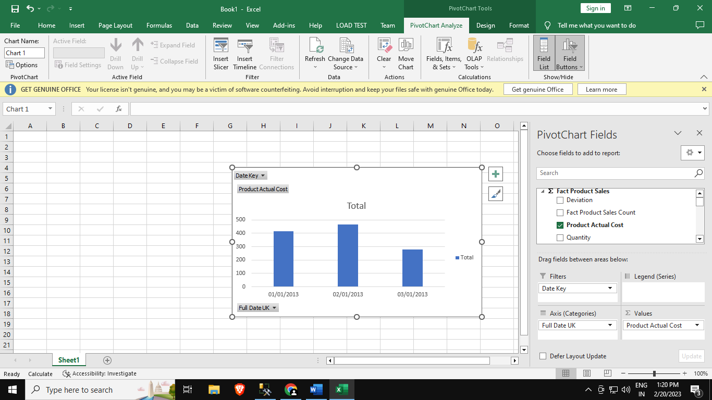

**Step 8: In Insert Tab→ go to Pivot Table**

**Step 9: Click on Choose Connection to select existing connection with Sales_DW and click on open**

**Pivot table and Pivot chart is created**

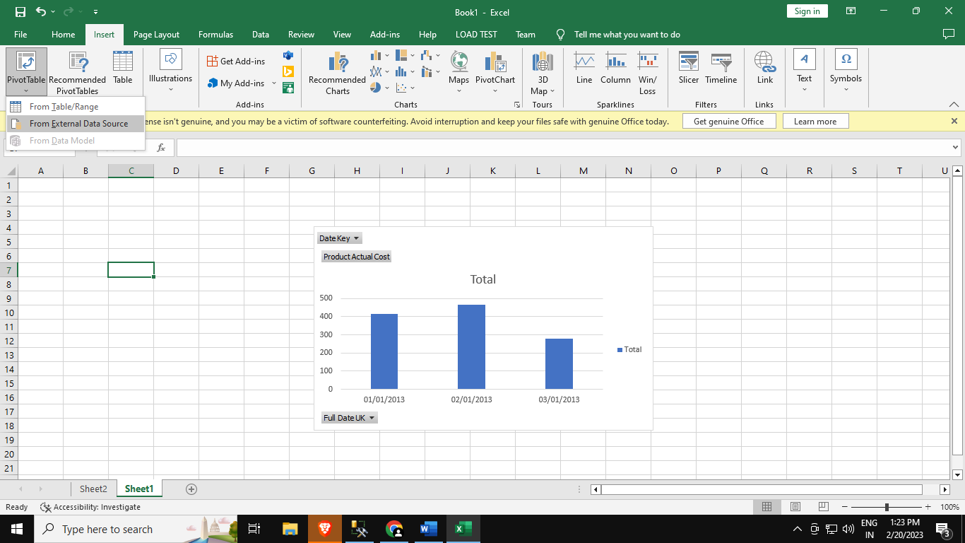

**Step 9: Click on Choose Connection to select existing connection with Sales_DW and click on open**

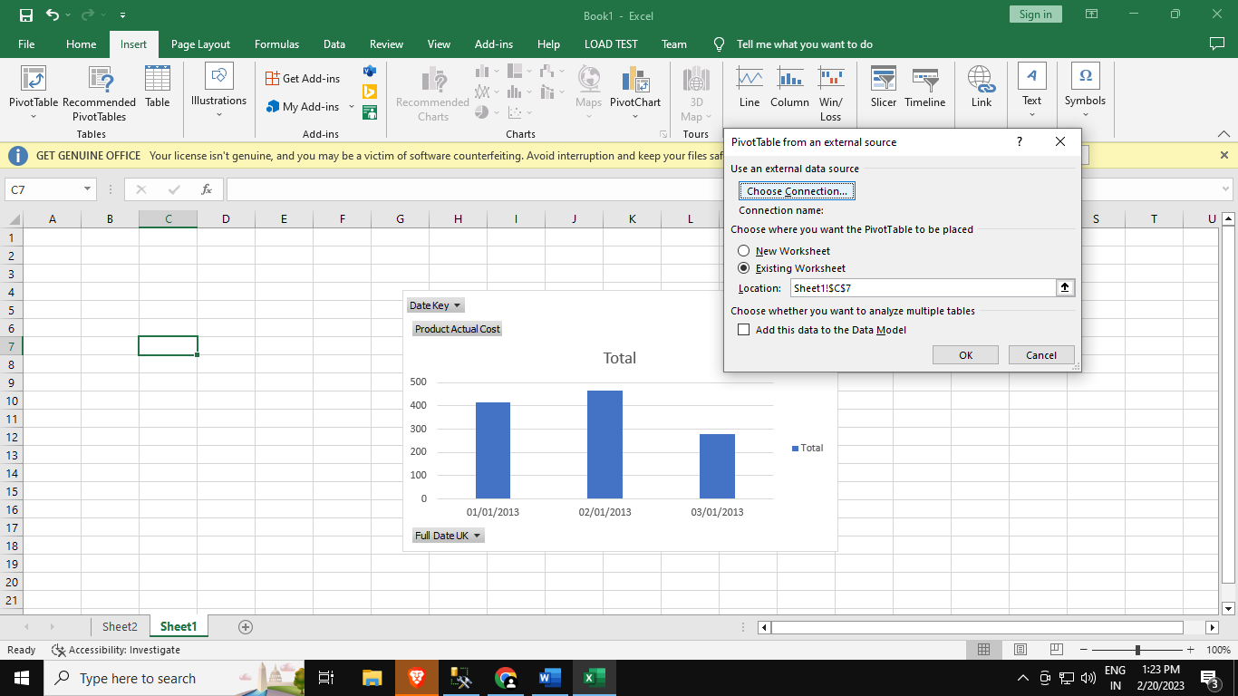

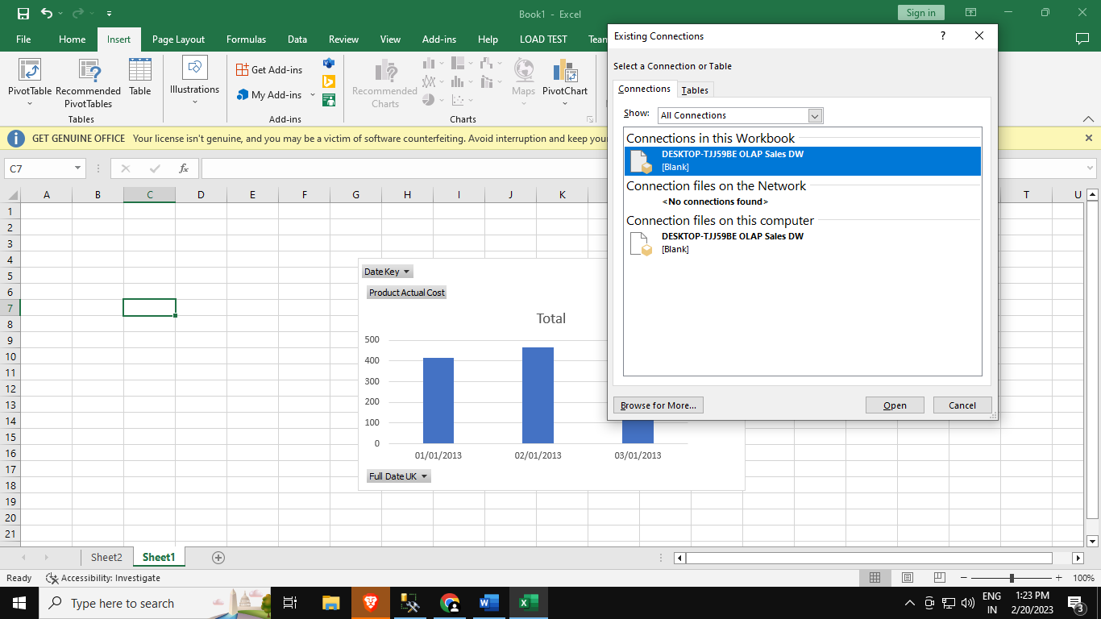

**Pivot table and Pivot chart is created**

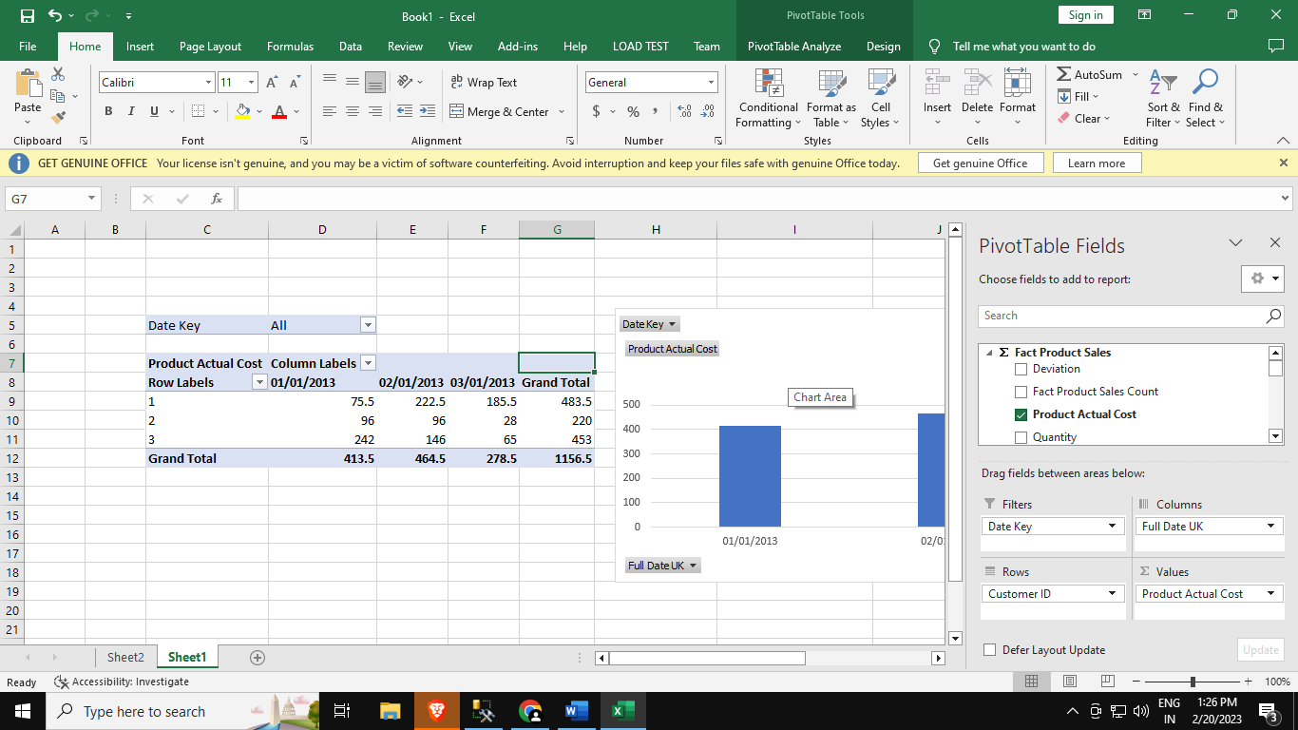

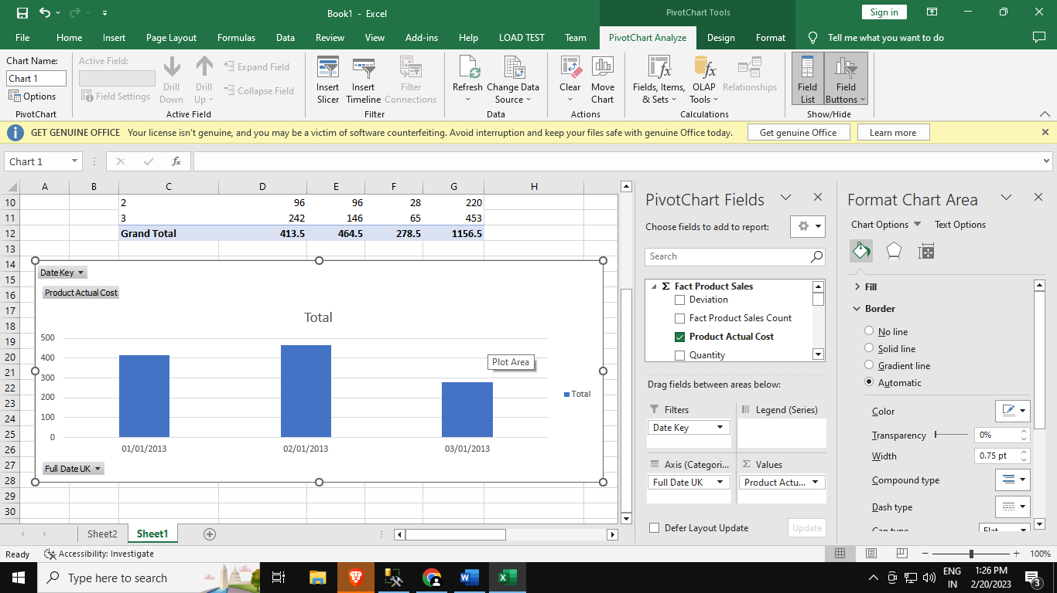

**Practicsl 5b :- Import the cube in Microsoft Excel and create the Pivot table and Pivot Chart To perform data analysis.**

**Step 1: Open Excel 2013 (Professional) itvoGo to Data tab rnal Data > From Other Sources > From Analysisers.in Go to Data tab Get External Data**

**Services**

**Step 2: Select Server name and Windows Authentication and click on Next**

**Step 3: Select OLAP (as per (as per created before) click on Next**

**Step 4: Browse and select path name and click on Finish**

**Data Connection Wizard**

**Step 5: Select PivotTableReport → OK**

**Step 6: Drag and Drop Fields in rows column and values**

**Step 7: Go to Insert tab pivot chart and select Pivot Chart from drop down**

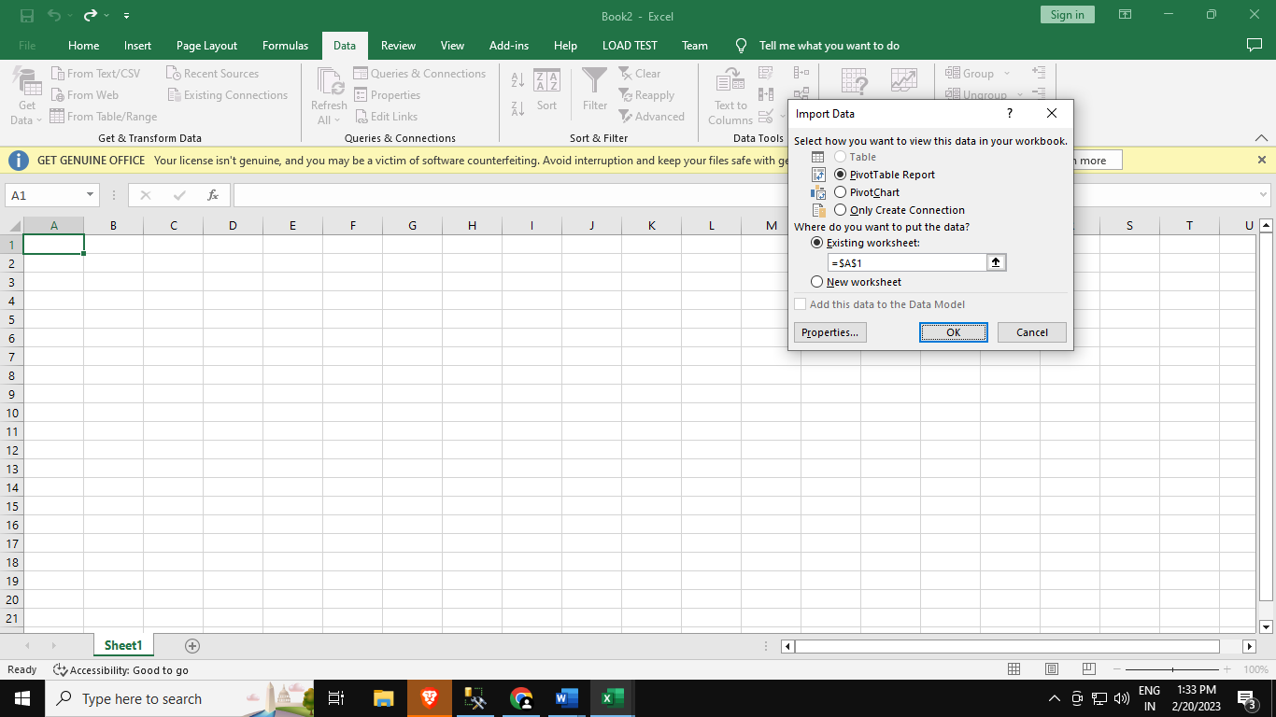

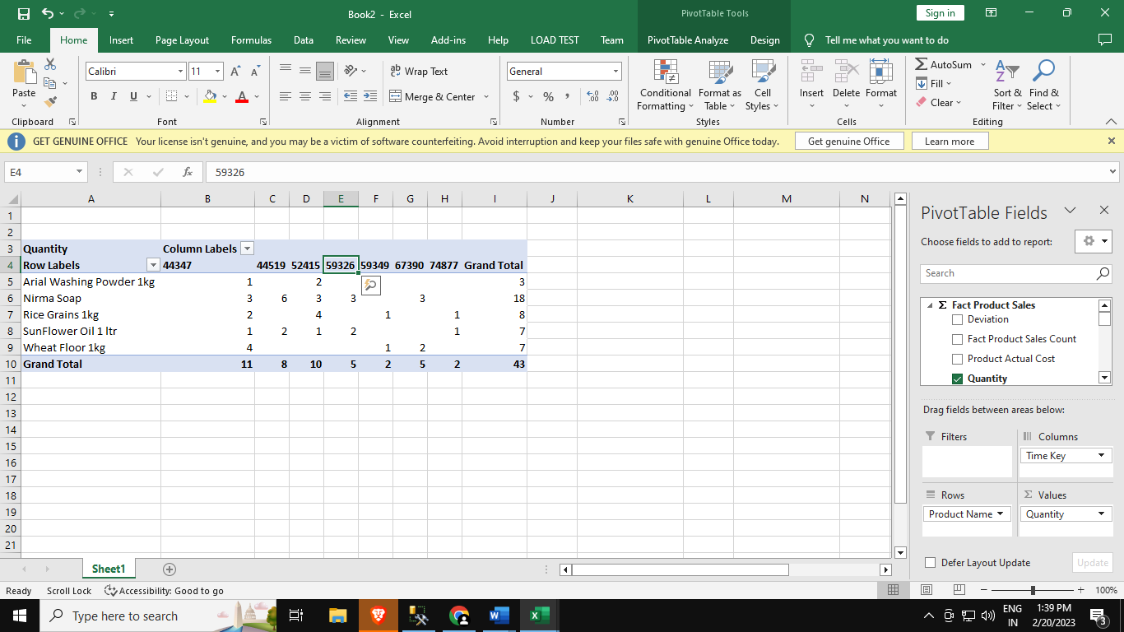

**Step 8: Select existing connection OLAP Sales DW and click on Open**

**Step 9: Click on Choose connection to select path**

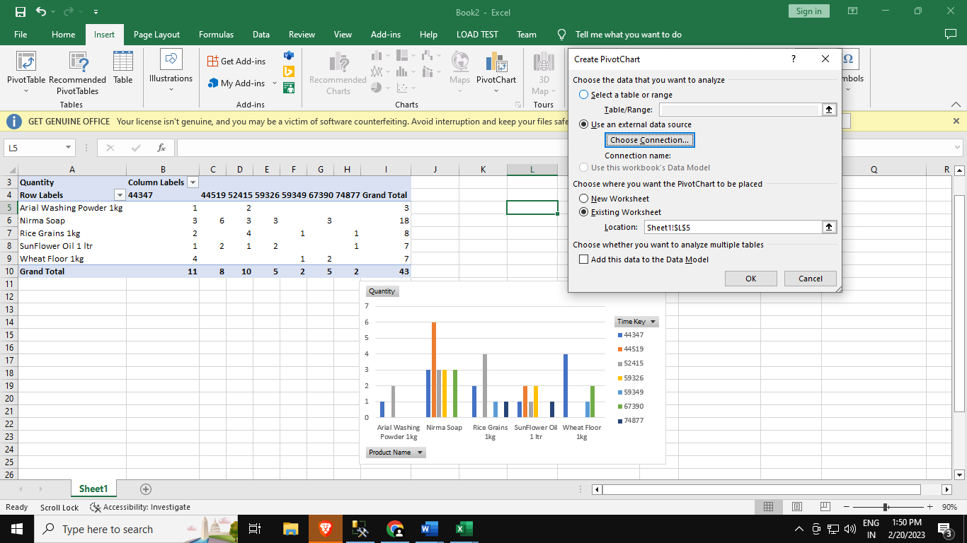

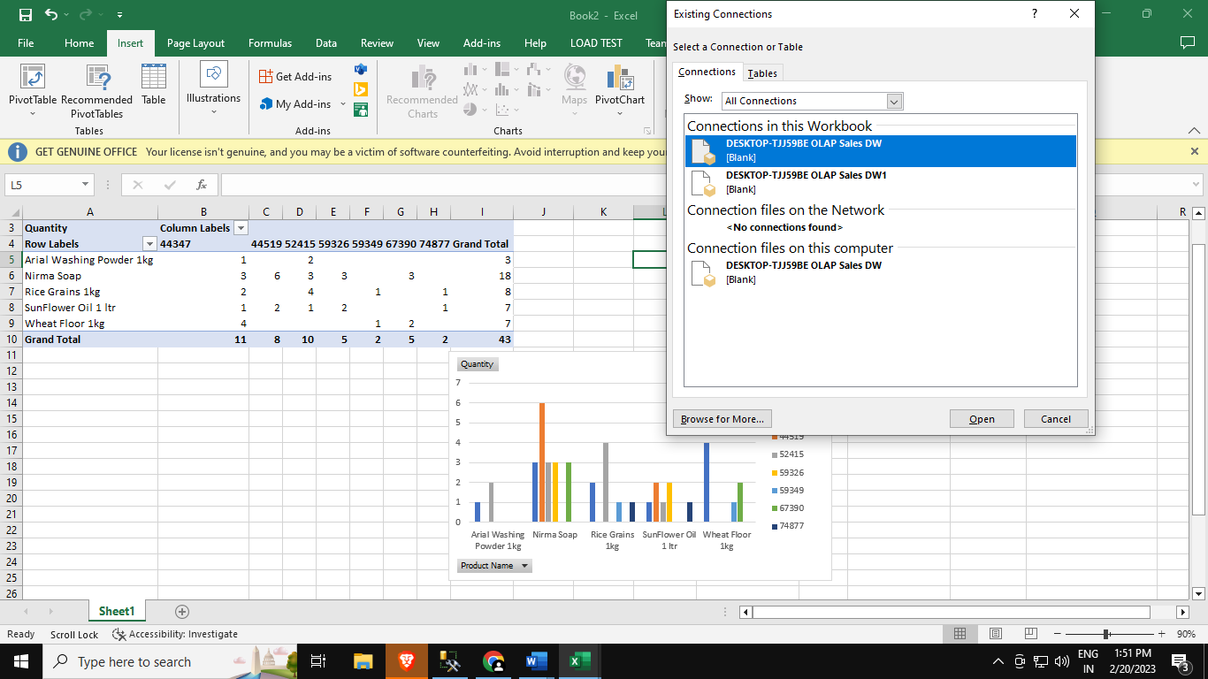

**Step 10: Click on OK**

